

**AMERICAN INTERNATIONAL UNIVERSITY – BANGLADESH**

**INTRODUCTION TO DATABASE**

**FALL- 2022-2023**

Supervise By

**Syed Nafiul Shefat**

**Project Topic: Orphanage Management System**

**Group No: 08**

**Section: G**

Submitted By:

|  |  |
| --- | --- |
| **NAME** | **ID** |
| MD.ASHIKUZZAMAN ABIR | 22-47006-1 |
| FARJANA YESMIN OPI | 22-47018-1 |
| MD. ABU TOWSIF | 22-47019-1 |
| MD. ZIDUL ALAM ZIM | 20-42902-1 |

**TABLE OF CONTENTS**

**TOPICS Page no.**

**1. Scenario Description 03**

**2. ER diagram 04**

**3. Normalization 05-17**

**5. Tables 18-19**

**6. Final Tables 20**

**7. Table Creation 21-28**

**8. Data Insertion 29-36**

**9. Constraints 37-41**

**10. Query Test 42-45**

**ORPHANAGE MANAGEMENT SYSTEM**

It’s 2122.Two great nations are conflicting against each other from a while. A great number of people are passing away every day as an impact of the war. As a result, many children are losing their parents. So, an international company took an initiative to shelter the orphans from the affected area to a safe place and established an orphanage. The orphanage has a database management system where orphanage’s unique registration ID, established date and location are stored. In this management system orphanage hires a manager. To identify manager the system stores manager ID, name, address, age, salary and phone number. The manager appointed some employees, known as the “O_COLLECTORS”, who collects orphans from the affected area and send them to the orphanage. These collectors have collector ID, name, salary, age, phone number and number of total collected orphan. The orphanage has also staffs, who take care of the orphans. Staffs are also appointed by the manager. Each staffs have staff ID, name, age, position, salary, joining date and address. Orphanage gives shelter to orphans. All orphans of the orphanage have unique orphan ID. Their name, age, collector name, country from where they were collected, collection date, blood group and gender are also stored in the database. There are some fixed donators, who donates to the orphanage regularly. Donating to the orphanage is open for all. The orphanage creates a unique donor ID whoever donates them. It also stores donor name, phone number, address, donation type, donation amount, first donation date of the donor. There are adopters who adopt the orphans as their family members. The orphanage creates an adopter ID whenever they adopt an orphan. Name, age, address, phone number, email address, NID number, adoption date and financial condition of the adopter are also stored. The orphanage has its own schooling system, where database system stores EIIN number and name of school. School has teachers having their own teacher ID, name, joining date, address, phone number and subject. One teacher may teach many orphans.  Here addresses and location are composed of house number, street number, city and country.

**ER DIAGRAM**

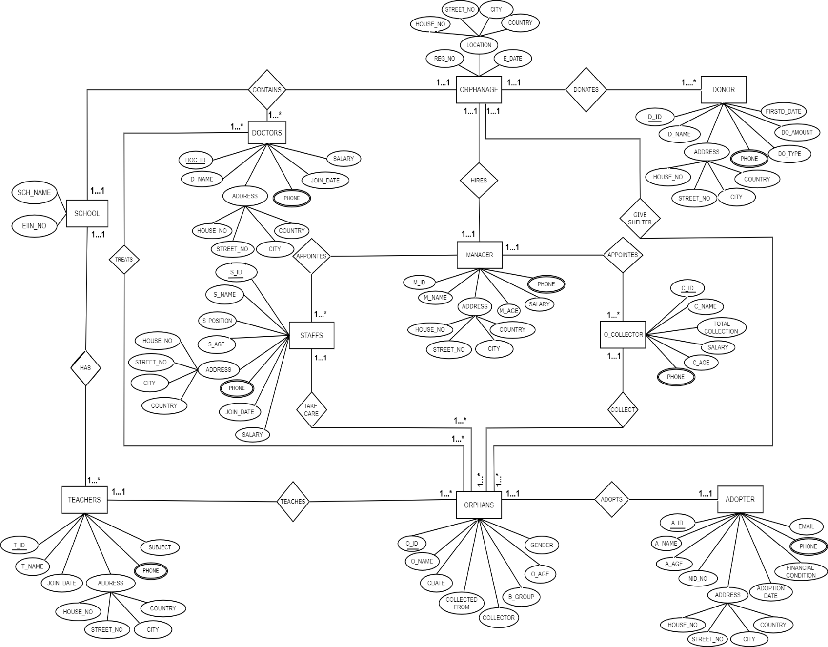

**NORMALIZATION:**

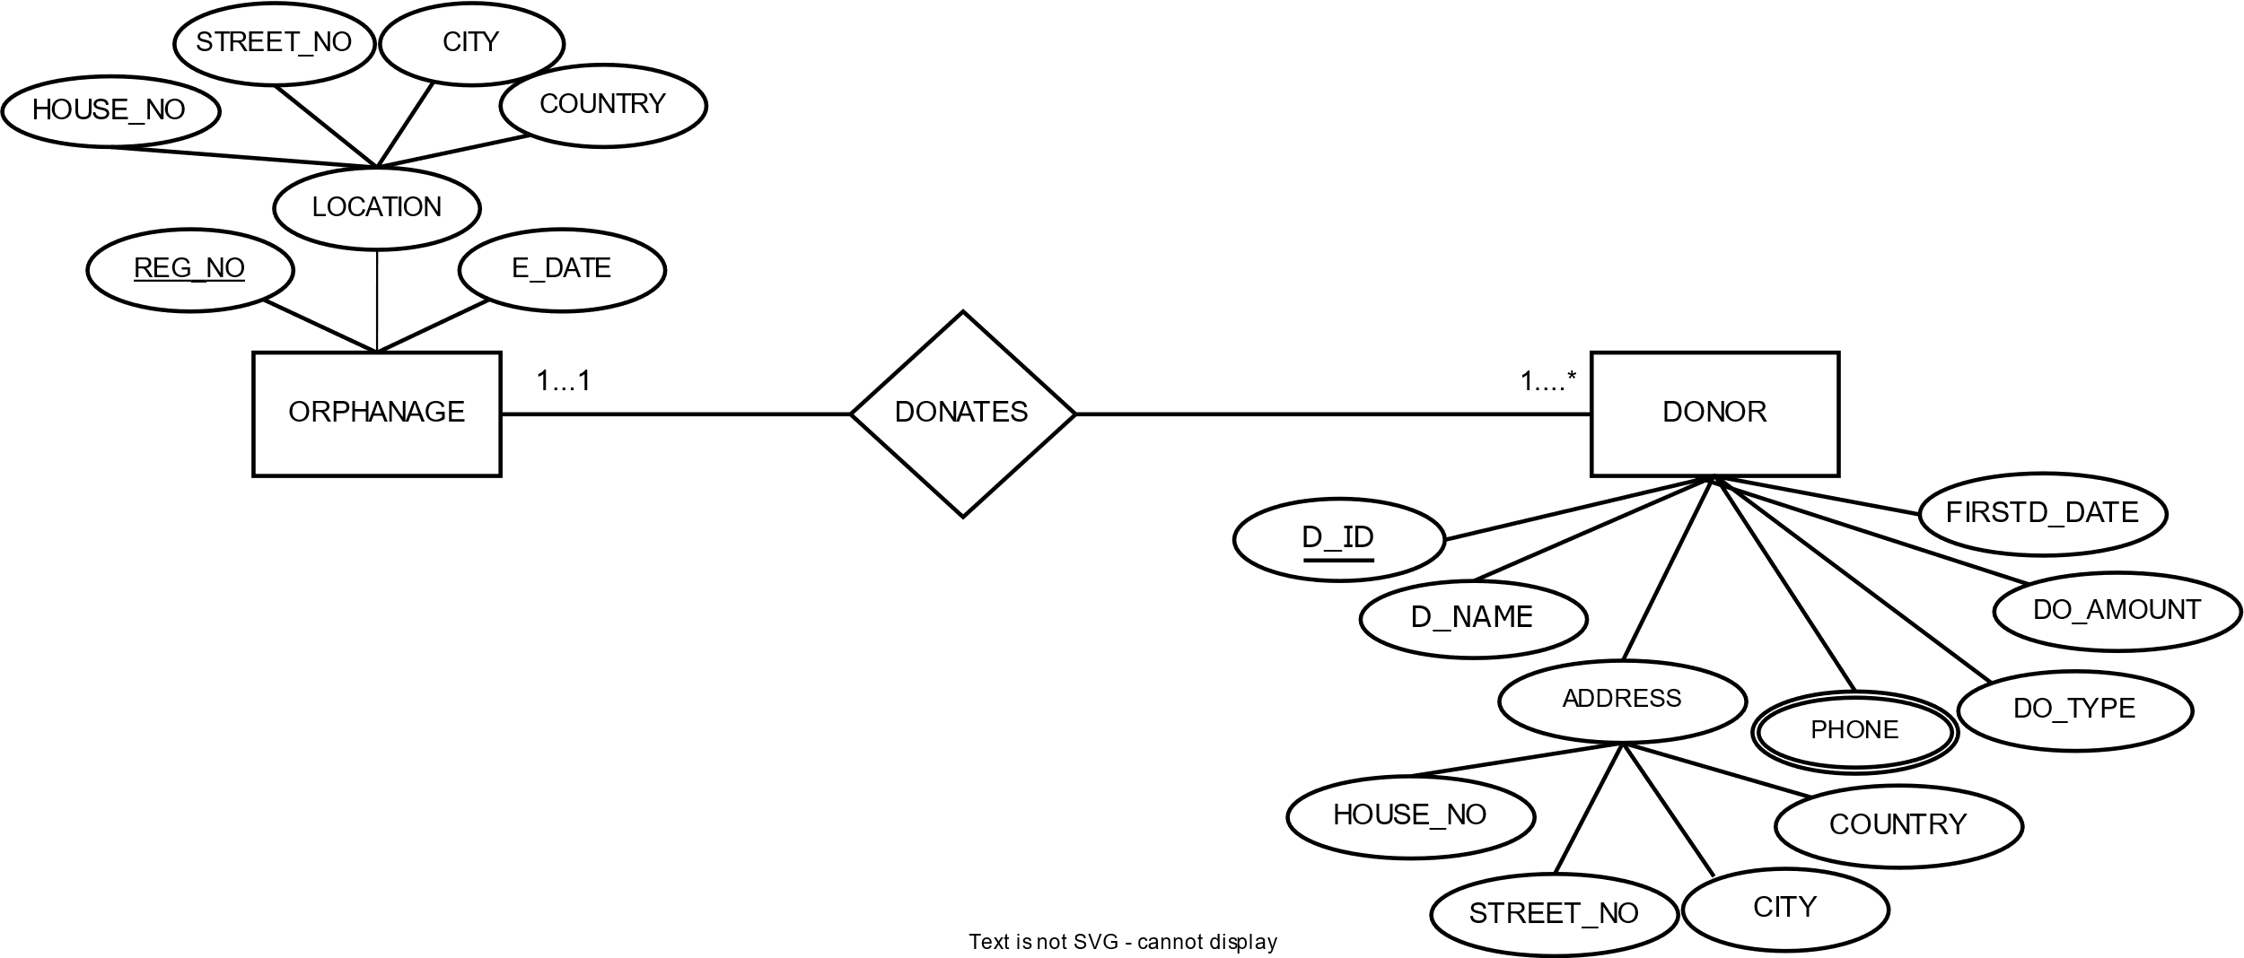

**DONATES:**

UNF:

REG_NO, E_DATE, HOUSE_NO, STREET_NO, CITY, COUNTRY, D_ID, D_NAME,

HOUSE_NO, STREET_NO, CITY, COUNTRY, PHONE, DO_TYPE, DO_AMOUNT, FIRSTD_DATE

1NF:

PHONE is a multivalued attribute

REG_NO, E_DATE, HOUSE_NO, STREET_NO, CITY, COUNTRY, D_ID, D_NAME,

HOUSE_NO, STREET_NO, CITY, COUNTRY, DO_TYPE, DO_AMOUNT, FIRSTD_DATE

2NF:

1. REG_NO, E_DATE, HOUSE_NO, STREET_NO, CITY, COUNTRY
2. DI_D, D_NAME, HOUSE_NO, STREET_NO, CITY, COUNTRY, DO_TYPE, DO_AMOUNT, FIRSTD_DATE, REG_NO, PHONE_ID
3. PHONE_ID, PHONE

3NF:

1. REG_NO, E_DATE, ADD_ID
2. ADD_ID, HOUSE_NO, STREET_NO, CITY, COUNTRY
3. DI_D, D_NAME, REG_NO, ADD_ID, PHONE_ID
4. ADD_ID, HOUSE_NO, STREET_NO, CITY, COUNTRY
5. D_ID, DO_TYPE, DO_AMOUNT, FIRSTD_DATE,
6. PHONE_ID, PHONE

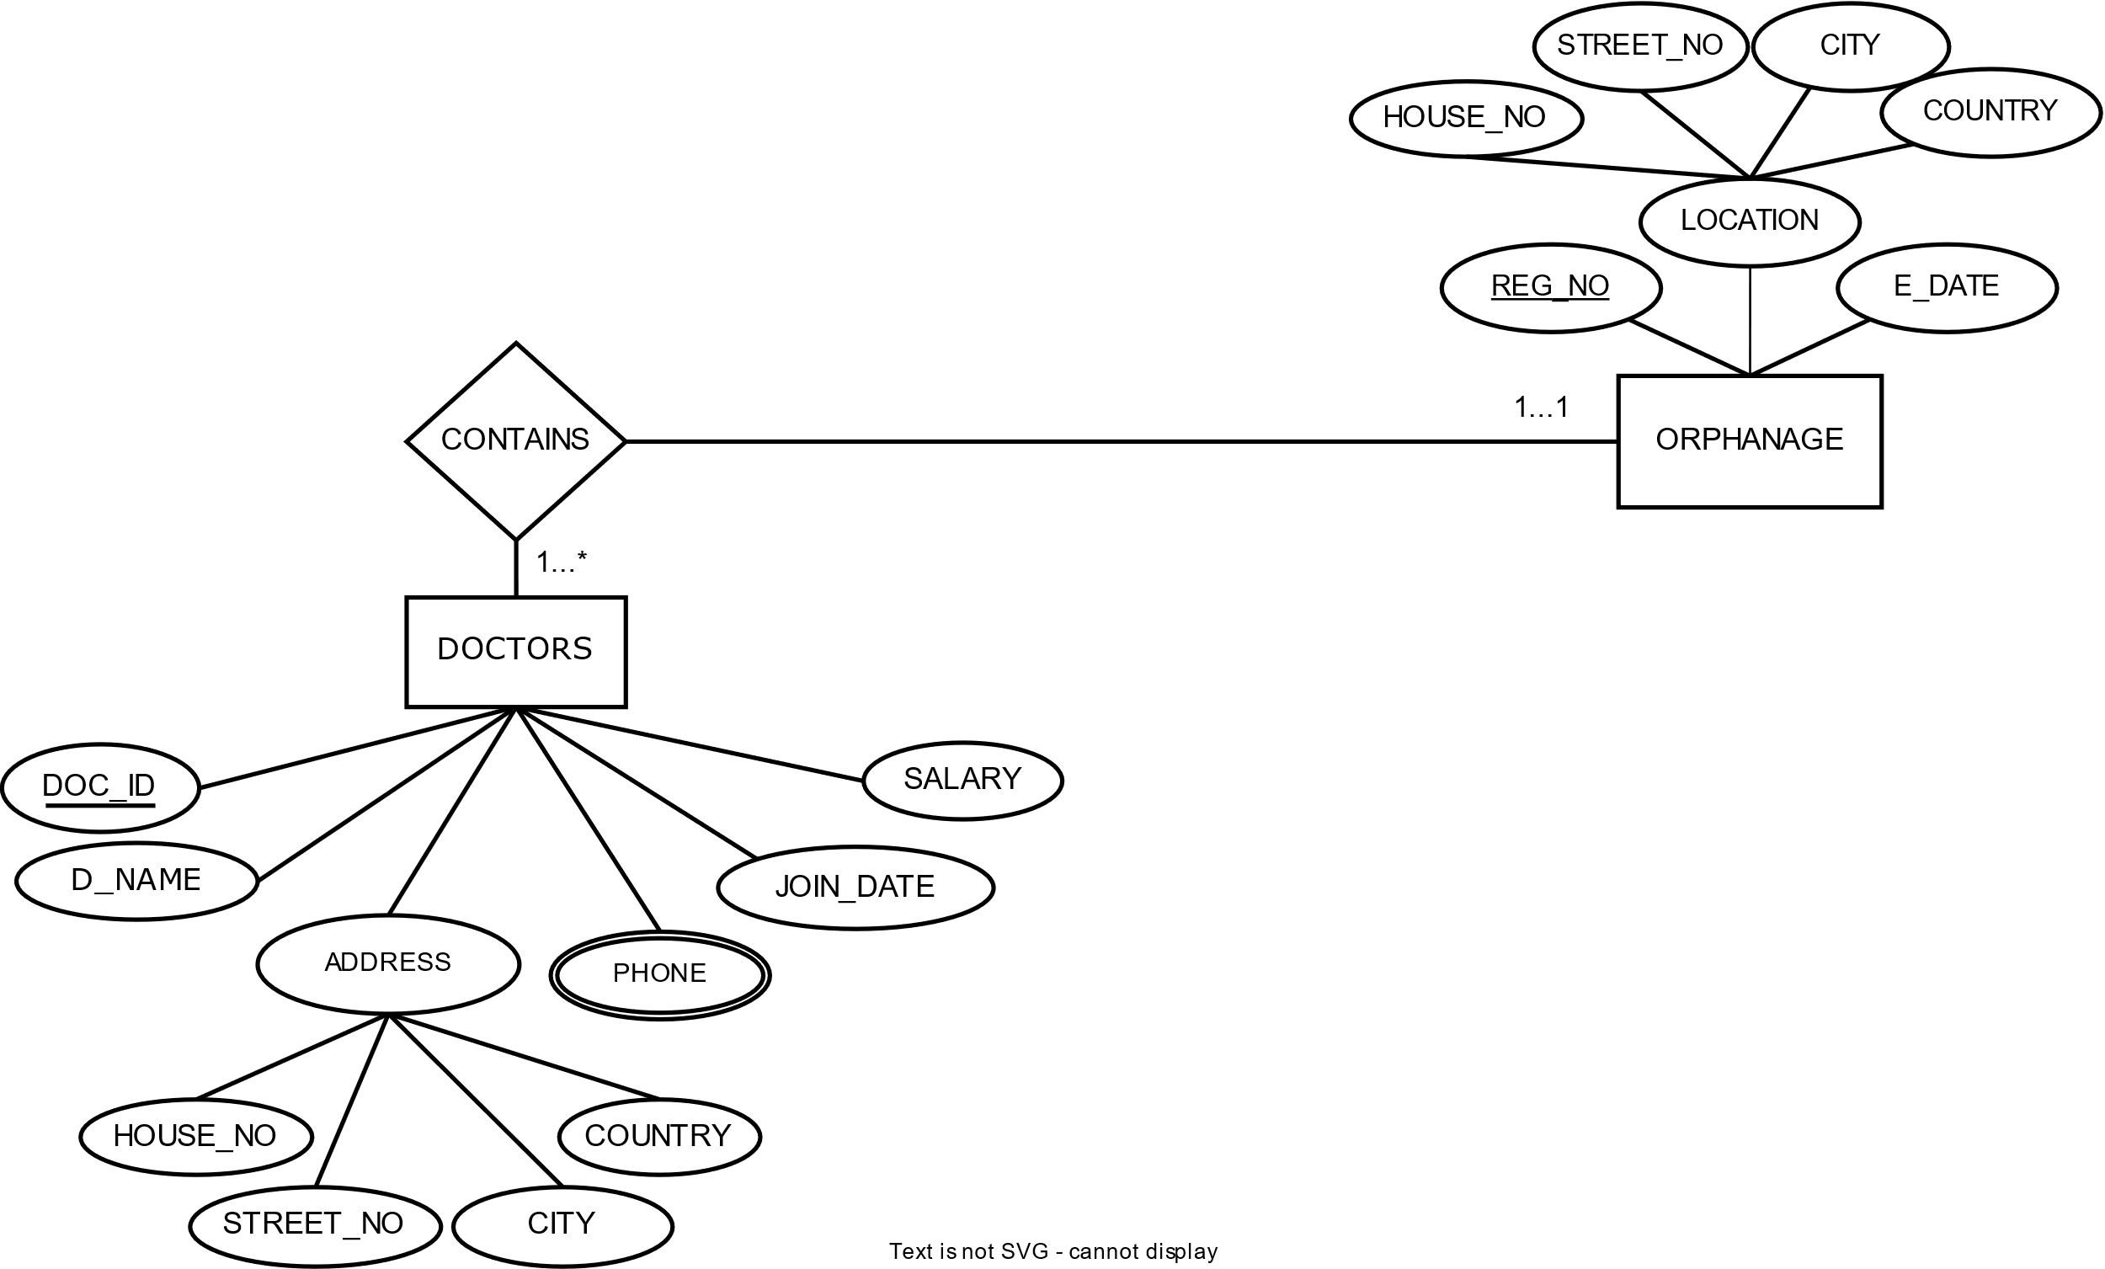

**CONTAINS:**

UNF:

REG_NO, E_DATE, HOUSE_NO, STREET_NO, CITY, COUNTRY, DOC_ID, DO_NAME, HOUSE_NO, STREET_NO, CITY, COUNTRY, PHONE, JOIN_DATE, SALARY

1NF:

PHONE is a multivalued attribute

REG_NO, E_DATE, HOUSE_NO, STREET_NO, CITY, COUNTRY, DOC_ID, DO_NAME, HOUSE_NO, STREET_NO, CITY, COUNTRY, JOIN_DATE, SALARY

2NF:

1. REG_NO, E_DATE, HOUSE_NO, STREET_NO, CITY, COUNTRY
2. DOC_ID, DO_NAME, HOUSE_NO, STREET_NO, CITY, COUNTRY, JOIN_DATE, SALARY, REG_NO, PHONE_ID
3. PHONE_ID, PHONE

3NF:

1. REG_NO, E_DATE, ADD_ID
2. ADD_ID, HOUSE_NO, STREET_NO, CITY, COUNTRY
3. DOC_ID, DO_NAME, JOIN_DATE, SALARY, REG_NO, PHONE_ID, ADD_ID
4. ADD_ID, HOUSE_NO, STREET_NO, CITY, COUNTRY
5. PHONE_ID, PHONE

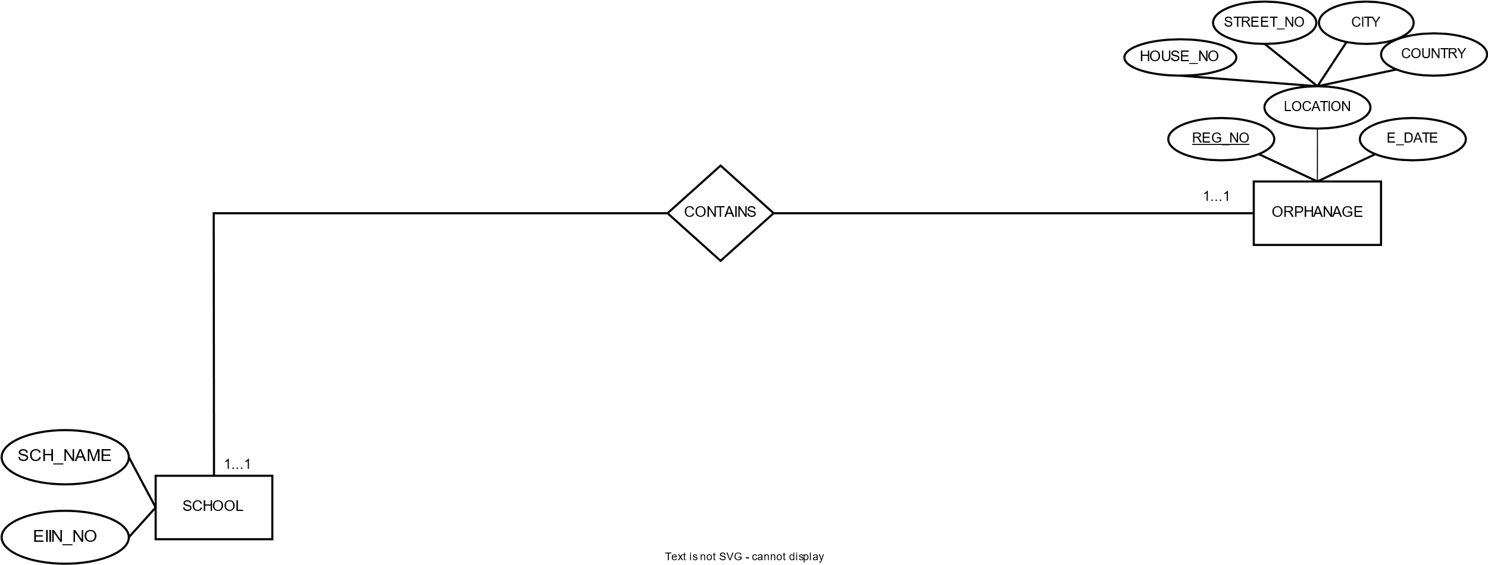

**CONTAIN**:

UNF:

REG_NO, REG_NO, E_DATE, HOUSE_NO, STREET_NO, CITY, COUNTRY, SCH_NAME, EIIN_NO

1NF:

REG_NO, REG_NO, E_DATE, HOUSE_NO, STREET_NO, CITY, COUNTRY, SCH_NAME, EIIN_NO

2NF:

1. REG_NO, E_DATE, HOUSE_NO, STREET_NO, CITY, COUNTRY
2. EIIN_NO, SCH_NAME, REG_NO

3NF:

1. REG_NO, E_DATE, ADD_ID
2. ADD_ID, HOUSE_NO, STREET_NO, CITY, COUNTRY
3. EIIN_NO, SCH_NAME, REG_NO

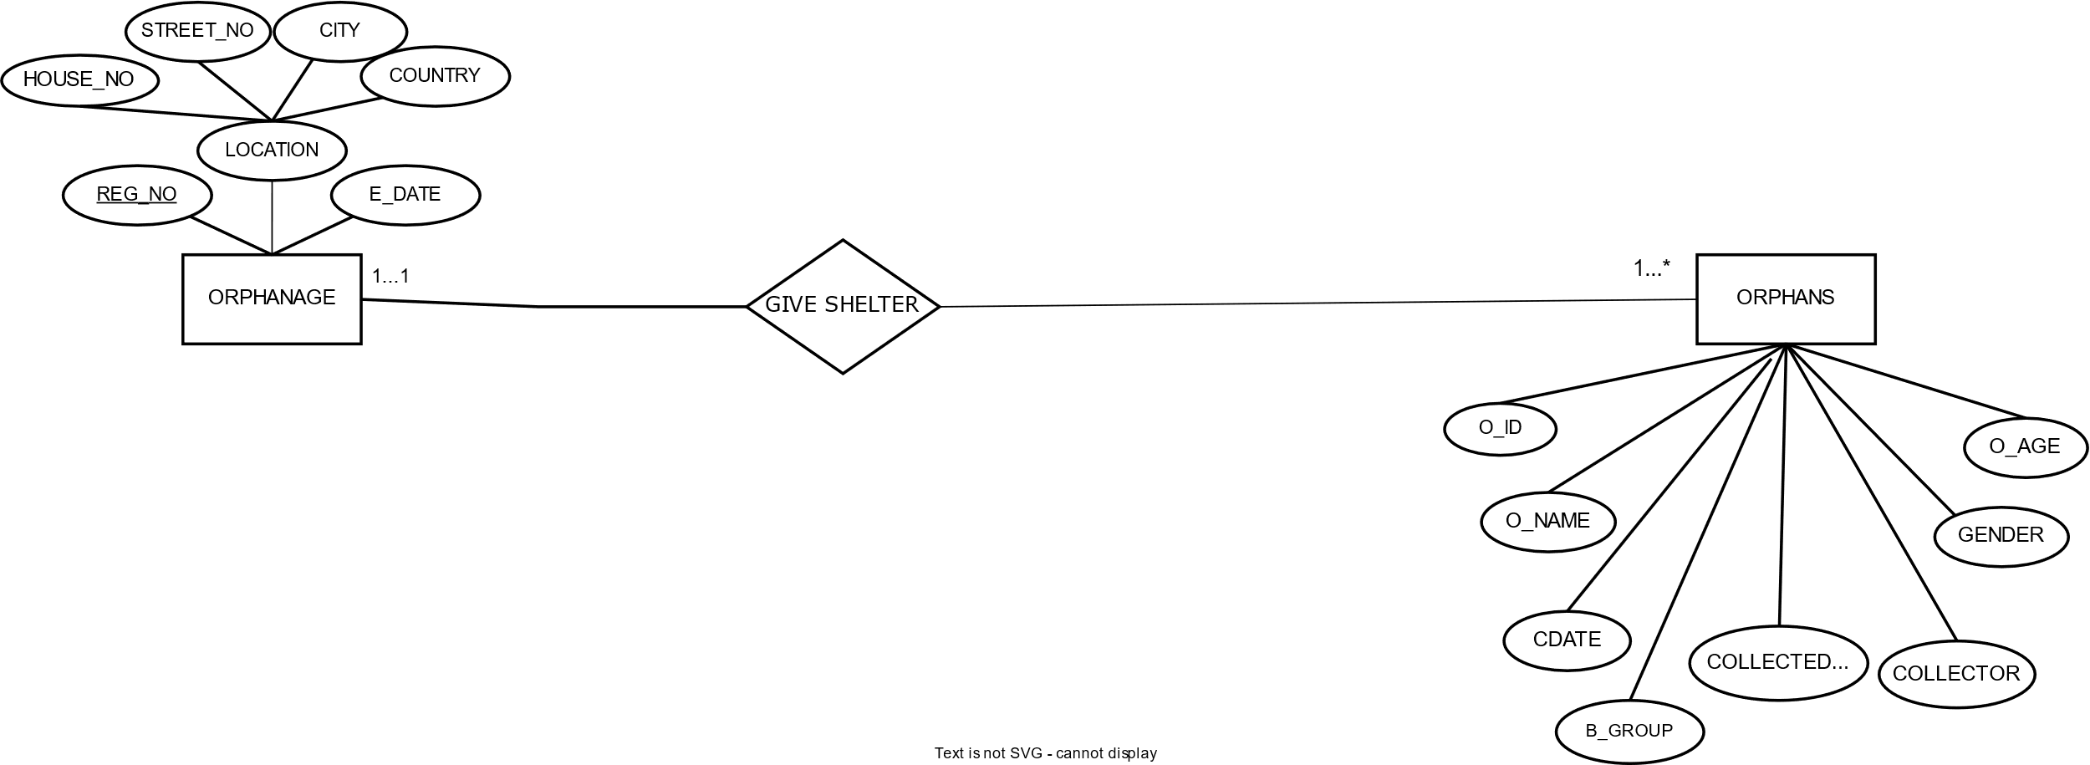

**GIVE SHELTER:**

UNF:

REG_NO, REG_NO, E_DATE, HOUSE_NO, STREET_NO, CITY, COUNTRY, O_ID, O_NAME, C_DATE, COLLECTED_FROM, COLLECTOR, B_GROUP, GENDER, O_AGE

1NF:

REG_NO, REG_NO, E_DATE, HOUSE_NO, STREET_NO, CITY, COUNTRY, O_ID, O_NAME, C_DATE, COLLECTED_FROM, COLLECTOR, B_GROUP, GENDER, O_AGE

2NF:

1. REG_NO, E_DATE, HOUSE_NO, STREET_NO, CITY, COUNTRY
2. O_ID, O_NAME, C_DATE, COLLECTED_FROM, COLLECTOR, B_GROUP, GENDER, O_AGE, REG_NO

3NF:

1. REG_NO, E_DATE, ADD_ID
2. ADD_AD, HOUSE_NO, STREET_NO, CITY, COUNTRY
3. O_ID, O_NAME, B-GROUP, GENGER, O_AGE, REG_NO
4. O_ID, C_DATE, COLLECTED_FROM, COLLECTOR

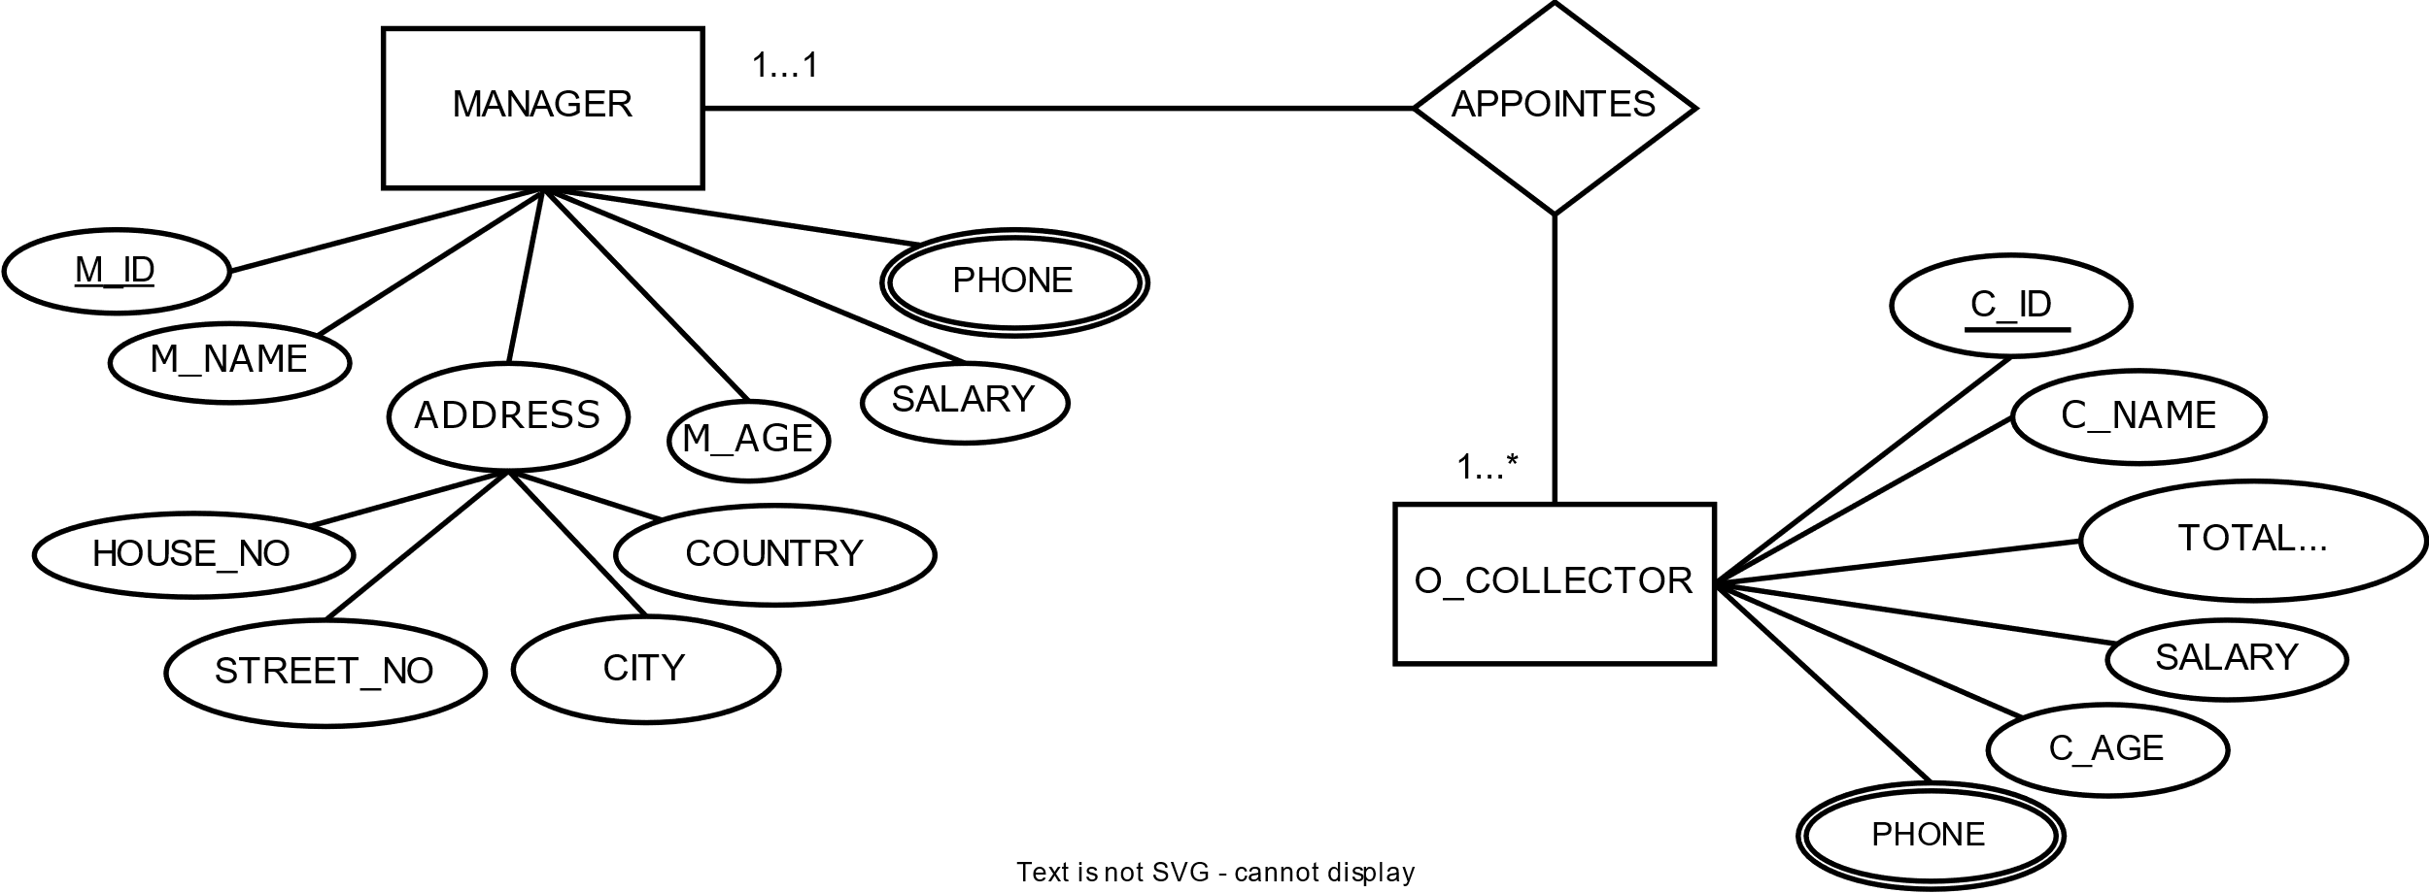

**APPOINTS:**

UNF:

M_ID, M_NAME, HOUSE_NO, STREET_NO, CITY, COUNTRY, M_AGE, SALARY, PHONE, C_ID, C_NAME, TOTAL_COLLECTION, SALARY, C_AGE, PHONE

1NF:

PHONE is a multivalued attribute

M_ID, M_NAME, HOUSE_NO, STREET_NO, CITY, COUNTRY, M_AGE, SALARY, C_ID, C_NAME, TOTAL_COLLECTION, SALARY, C_AGE,

2NF:

1. M_ID, M_NAME, HOUSE_NO, STREET_NO, CITY, COUNTRY, M_AGE, SALARY, PHONE_ID
2. PHONE_ID, PHONE
3. C_ID, C_NAME, TOTAL_COLLECTION, SALARY, C_AGE, M_ID, PHONE_ID
4. PHONE_ID, PHONE

3NF:

1. M_ID, M_NAME, M_AGE, SALARY, PHONE_ID, ADD_ID
2. ADD_ID, HOUSE_NO, STREET_NO, CITY, COUNTRY
3. PHONE_ID, PHONE
4. C_ID, C_NAME, TOTAL_COLLECTION, SALARY, C_AGE, M_ID, PHONE_ID
5. PHONE_ID, PHONE

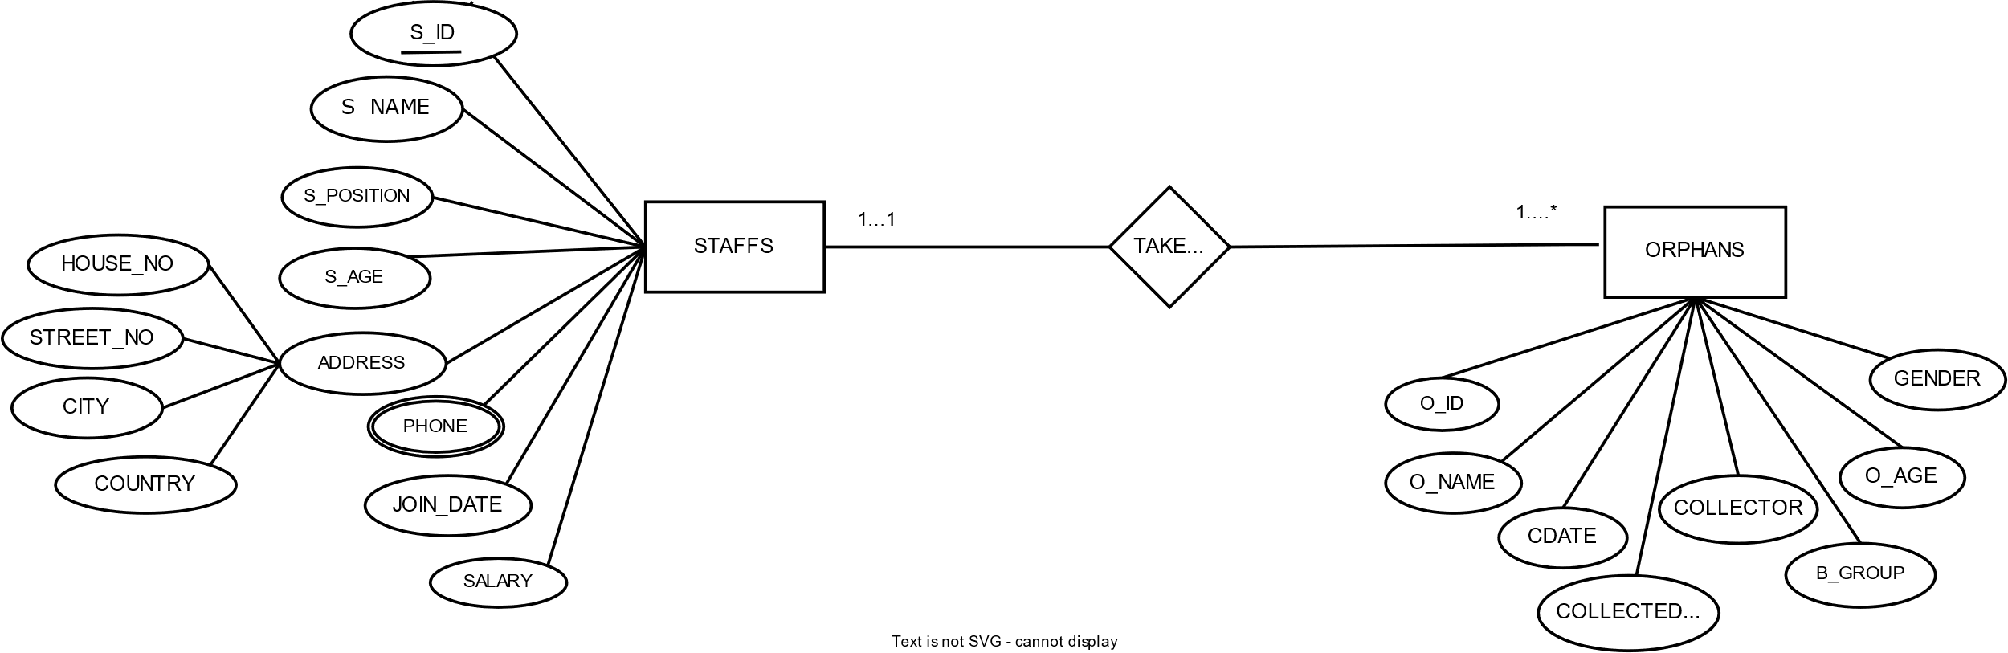

**TAKE CARE:**

UNF:

S_ID, S_NAME, S_POSITION, S_AGE, HOUSE_NO, STREET_NO, CITY, COUNTRY, PHONE, JOIN_DATE, SALARY, O_ID, O_NAME, C_DATE, COLLECTED_FROM, COLLECTOR, B_GROUP, GENDER, O_AGE

1NF:

PHONE is a multivalued attribute

S_ID, S_NAME, S_POSITION, S_AGE, HOUSE_NO, STREET_NO, CITY, COUNTRY, JOIN_DATE, SALARY, O_ID, O_NAME, C_DATE, COLLECTED_FROM, COLLECTOR, B_GROUP, GENDER, O_AGE

2NF:

1. S_ID, S_NAME, S_POSITION, S_AGE, HOUSE_NO, STREET_NO, CITY, COUNTRY, JOIN_DATE, SALARY, PHONE_ID
2. PHONE_ID, PHONE
3. O_ID, O_NAME, C_DATE, COLLECTED_FROM, COLLECTOR, B_GROUP, GENDER, O_AGE, S_ID

3NF:

1. S_ID, S_NAME, S_AGE, JOIN_DATE, ADD_ID, PHONE_ID
2. S_ID, S_POSITION, SALARY
3. ADD_ID, HOUSE_NO, STREET_NO, CITY, COUNTRY
4. PHONE_ID, PHONE
5. O_ID, O_NAME, B-GROUP, GENGER, O_AGE, S_ID
6. O_I D, C_DATE, COLLECTED_FROM, COLLECTOR

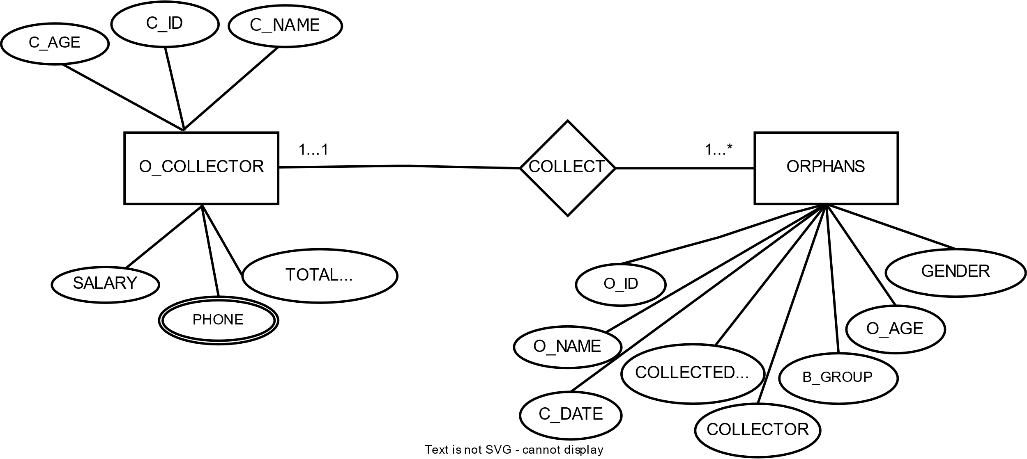

**COLLECT:**

UNF:

C_ID, C_NAME, TOTAL_COLLECTION, SALARY, C_AGE, PHONE, O_ID, O_NAME, C_DATE, COLLECTED_FROM, COLLECTOR, B_GROUP, GENDER, O_AGE

1NF:

PHONE is a multivalued attribute

C_ID, C_NAME, TOTAL_COLLECTION, SALARY, C_AGE, O_ID, O_NAME, C_DATE, COLLECTED_FROM, COLLECTOR, B_GROUP, GENDER, O_AGE

2NF:

1. C_ID, C_NAME, TOTAL_COLLECTION, SALARY, C_AGE, PHONE_ID
2. PHONE_ID, PHONE
3. O_ID, O_NAME, C_DATE, COLLECTED_FROM, COLLECTOR, B_GROUP, GENDER, O_AGE, C_ID

3NF:

1. C_ID, C_NAME, TOTAL_COLLECTION, SALARY, C_AGE, PHONE_ID
2. PHONE_ID, PHONE
3. O_ID, O_NAME, B_GROUP, GENDER, O_AGE, C_ID
4. O_ID, C_DATE, COLLECTED_FROM, COLLECTOR

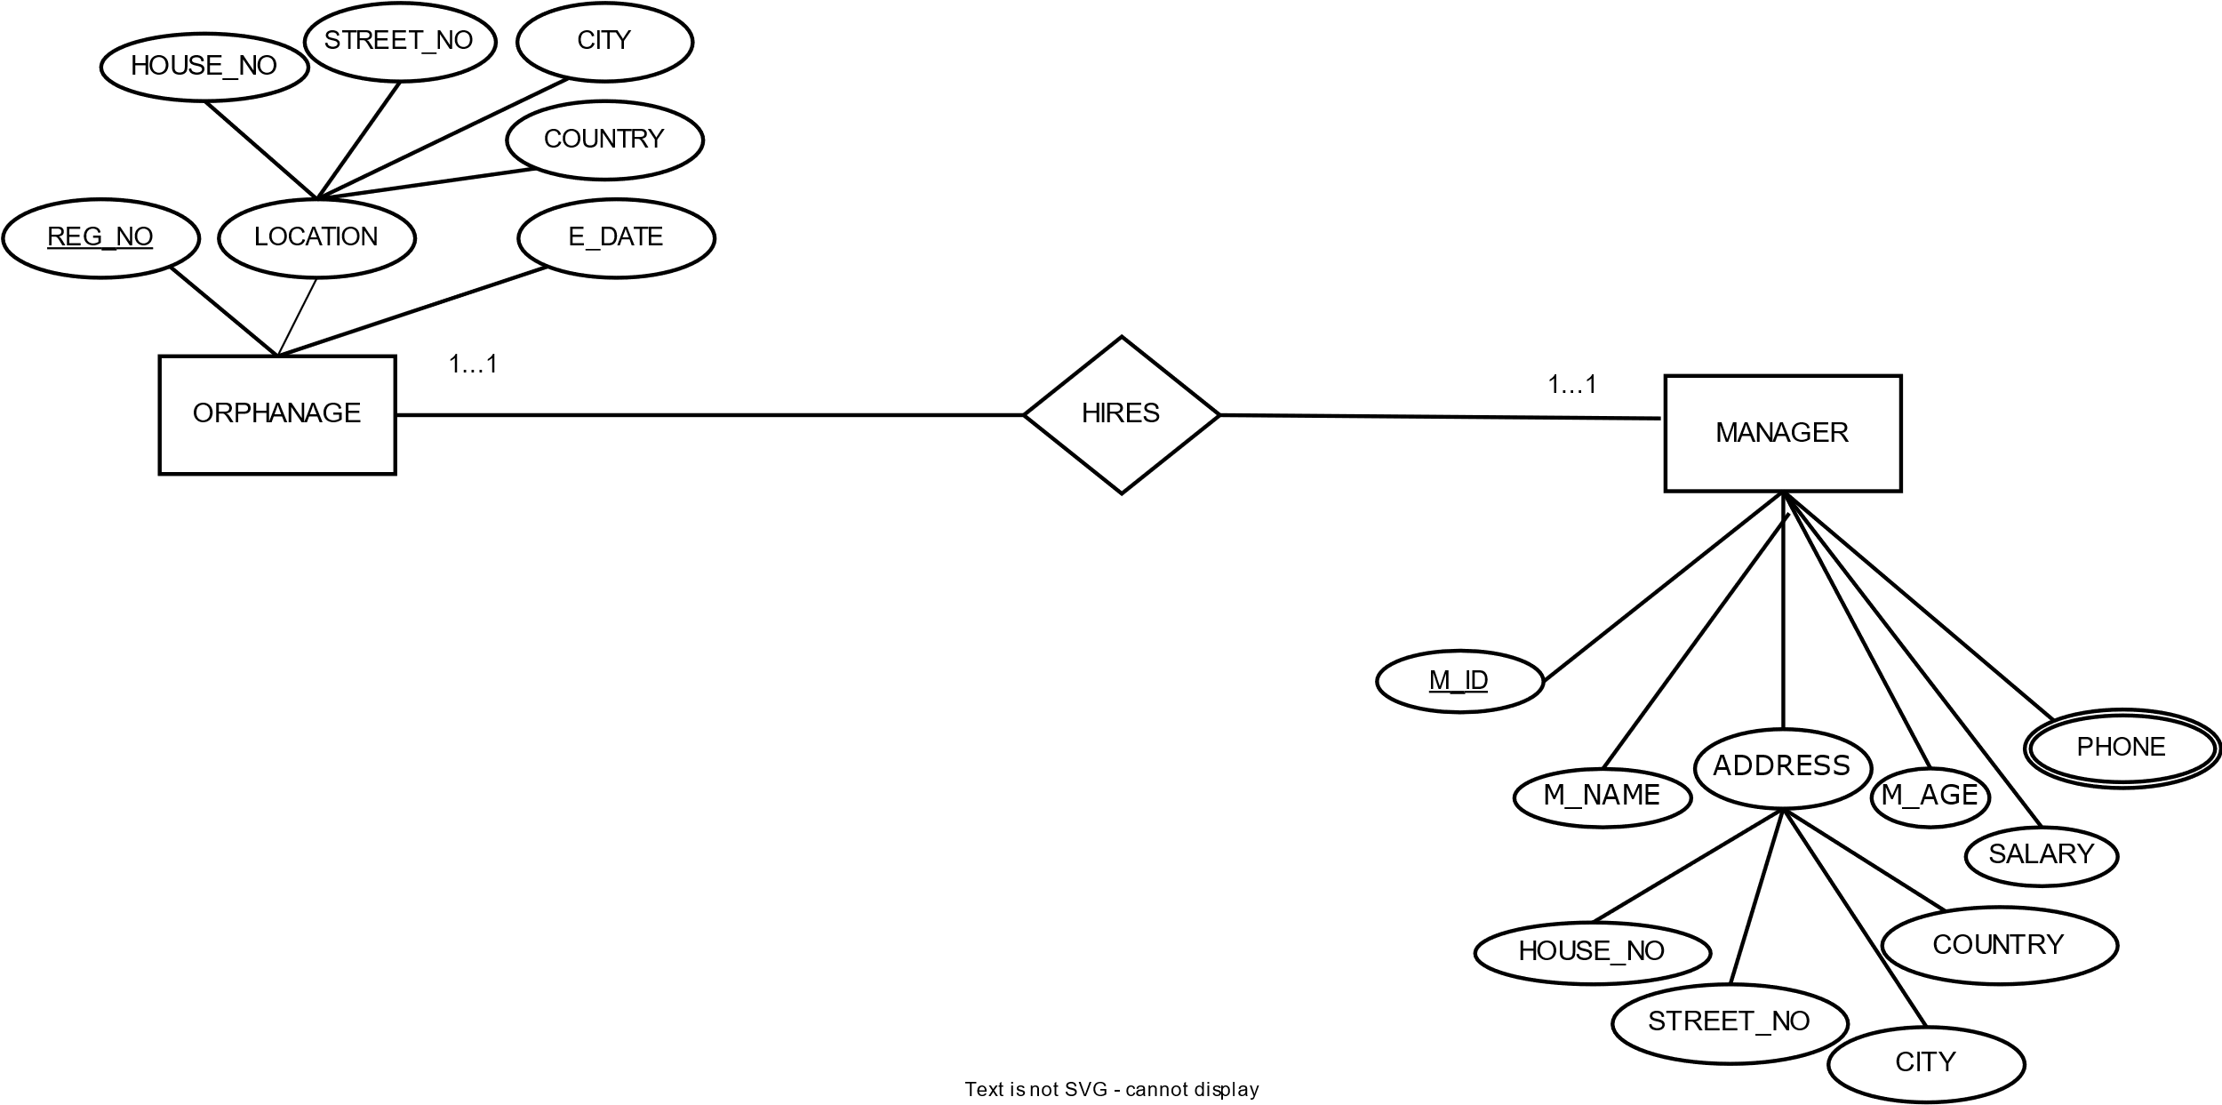**HIRES:**

UNF:

REG_NO, E_DATE, HOUSE_NO, STREET_NO, CITY, COUNTRY, M_ID, M_NAME, HOUSE_NO, STREET_NO, CITY, COUNTRY, M_AGE, SALARY, PHONE

1NF:

PHONE is a multivalued attribute.

REG_NO, E_DATE, HOUSE_NO, STREET_NO, CITY, COUNTRY, M_ID, M_NAME, HOUSE_NO, STREET_NO, CITY, COUNTRY, M_AGE, SALARY

2NF:

1. REG_NO, E_DATE, HOUSE_NO, STREET_NO, CITY, COUNTRY
2. M_ID, M_NAME, HOUSE_NO, STREET_NO, CITY, COUNTRY, M_AGE, SALARY, REG_NO, PHONE_ID
3. PHONE_ID, PHONE

3NF:

1. REG_NO, E_DATE, ADD_ID
2. ADD_ID, HOUSE_NO, STREET_NO, CITY, COUNTRY
3. M_ID, M_NAME, M_AGE, SALARY, REG_NO, PHONE_ID, ADD_ID
4. ADD_ID, HOUSE_NO, STREET_NO, CITY, COUNTRY
5. PHONE_ID, PHONE

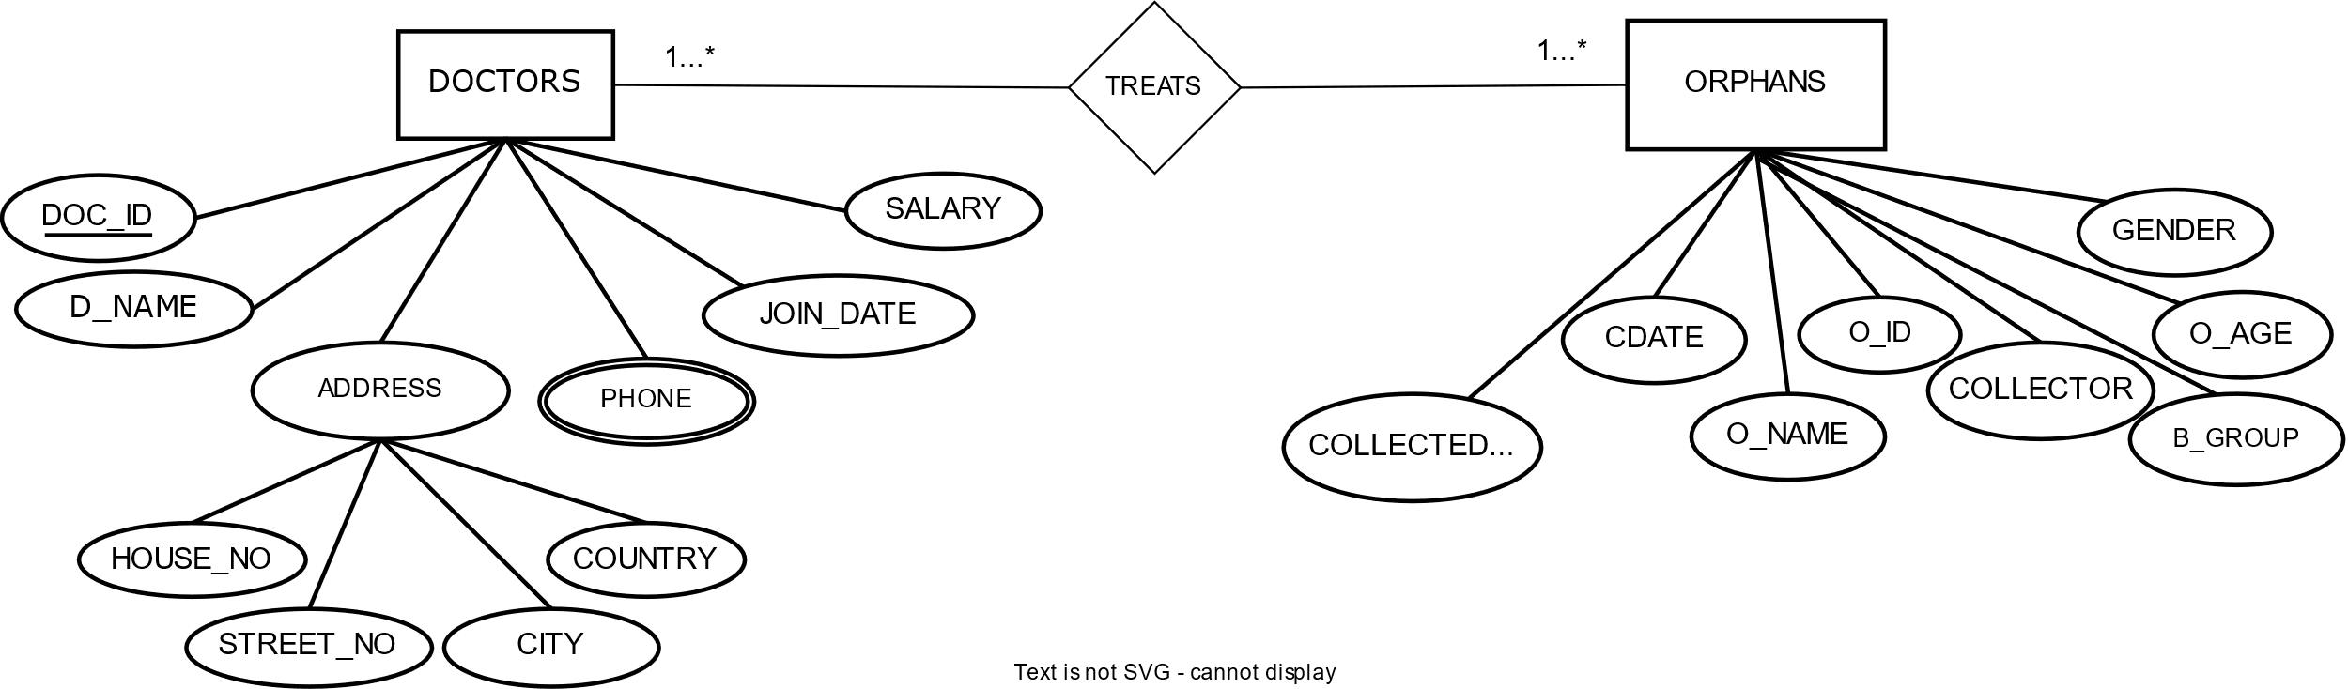

**TREATS:**

UNF:

DOC_ID, DO_NAME, HOUSE_NO, STREET_NO, CITY, COUNTRY, PHONE, JOIN_DATE, SALARY, O_ID, O_NAME, C_DATE, COLLECTED_FROM, COLLECTOR, B_GROUP, GENDER, O_AGE

1NF:

PHONE is a multivalued attribute

DOC_ID, DO_NAME, HOUSE_NO, STREET_NO, CITY, COUNTRY, JOIN_DATE, SALARY, O_ID, O_NAME, C_DATE, COLLECTED_FROM, COLLECTOR, B_GROUP, GENDER, O_AGE

2NF:

1. DOC_ID, DO_NAME, HOUSE_NO, STREET_NO, CITY, COUNTRY, JOIN_DATE, SALARY, PHONE_ID
2. PHONE_ID, PHONE
3. O_ID, O_NAME, C_DATE, COLLECTED_FROM, COLLECTOR, B_GROUP, GENDER, O_AGE, DOC_ID

3NF:

1. DOC_ID, DO_NAME, JOIN_DATE, SALARY, ADD_ID, PHONE_ID
2. ADD_ID, HOUSE_NO, STREET_NO, CITY, COUNTRY
3. PHONE_ID, PHONE
4. O_ID, O_NAME, B_GROUP, GENGER, O_AGE, DOC_ID
5. O_I D, C_DATE, COLLECTED_FROM, COLLECTOR

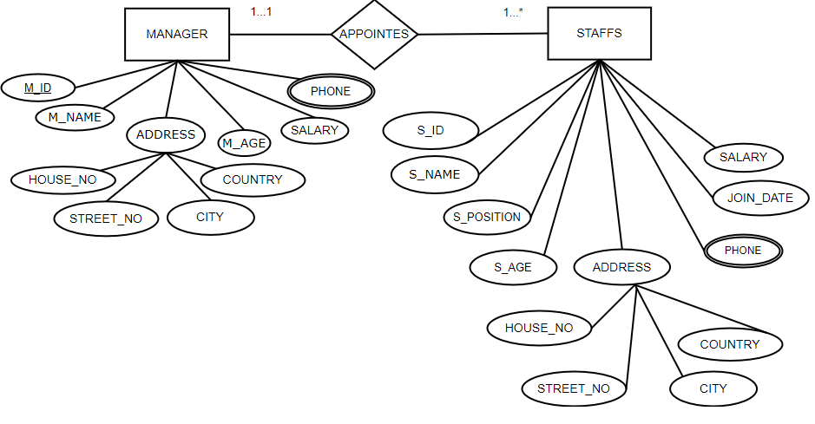

**APPOINTES:**

UNF:

M_ID, M_NAME, HOUSE_NO, STREET_NO, CITY, COUNTRY, M_AGE, SALARY, PHONE, S_ID, S_NAME, S_POSITION, S_AGE, HOUSE_NO, STREET_NO, CITY, COUNTRY, PHONE, JOIN_DATE, SALARY

1NF:

PHONE is a multivalued attribute.

M_ID, M_NAME, HOUSE_NO, STREET_NO, CITY, COUNTRY, M_AGE, SALARY, S_ID, S_NAME, S_POSITION, S_AGE, HOUSE_NO, STREET_NO, CITY, COUNTRY, JOIN_DATE, SALARY

2NF:

1. M_ID, M_NAME, HOUSE_NO, STREET_NO, CITY, COUNTRY, M_AGE, SALARY, PHONE_ID
2. PHONE_ID, PHONE
3. S_ID, S_NAME, S_POSITION, S_AGE, HOUSE_NO, STREET_NO, CITY, COUNTRY, JOIN_DATE, SALARY, M_ID, PHONE_ID
4. PHONE_ID, PHONE

3NF:

1. M_ID, M_NAME, M_AGE, SALARY, ADD_ID, PHONE_ID
2. ADD_ID, HOUSE_NO, STREET_NO, CITY, COUNTRY
3. PHONE_ID, PHONE
4. S_ID, S_NAME, S_AGE, JOIN_DATE, M_ID, ADD_ID, PHONE_ID
5. S_ID, S_POSITION, SALARY
6. ADD_ID, HOUSE_NO, STREET_NO, CITY, COUNTRY
7. PHONE_ID, PHONE

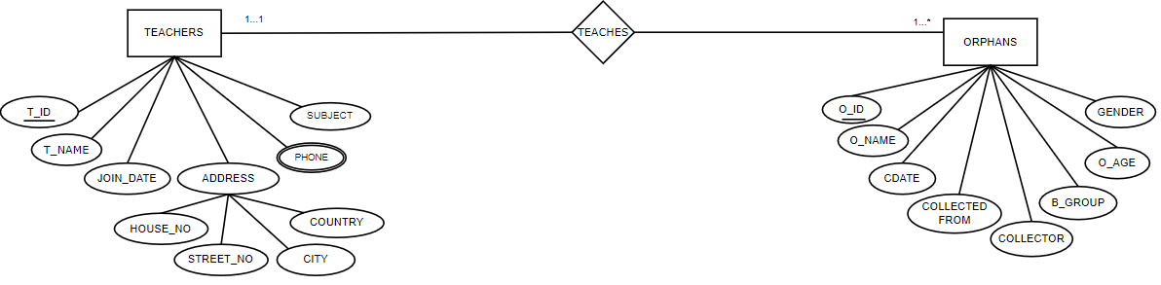

**TEACHES:**

UNF:

T_ID, T_NAME, SUBJECT, PHONE, JOIN_DATE, HOUSE_NO, STREET_NO, CITY, COUNTRY, O_ID, O_NAME, GENDER, O_AGE, B_GROUP, C_DATE, COLLECTED FROM, COLLECTOR

1NF:

PHONE is a multivalued attribute.

T_ID, T_NAME, SUBJECT, JOIN_DATE, HOUSE_NO, STREET_NO, CITY, COUNTRY, O_ID, O_NAME, GENDER, O_AGE, B_GROUP, C_DATE, COLLECTED FROM, COLLECTOR

2NF:

1. T_ID, T_NAME, SUBJECT, JOIN_DATE, HOUSE_NO, STREET_NO, CITY, COUNTRY, PHONE_ID
2. PHONE_ID, PHONE
3. O_ID, O_NAME, GENDER, O_AGE, B_GROUP, C_DATE, COLLECTED FROM, COLLECTOR, T_ID

3NF:

1. T_ID, T_NAME, SUBJECT, JOIN_DATE, PHONE_ID, ADD_ID
2. PHONE_ID, PHONE
3. ADD_ID HOUSE_NO, STREET_NO, CITY, COUNTRY
4. O_ID, O_NAME, GENDER, O_AGE, B_GROUP, T_ID
5. O_I D, C_DATE, COLLECTED_FROM, COLLECTOR

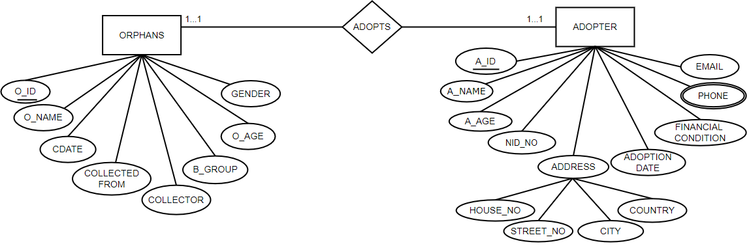

**ADOPTS:**

UNF:

A_ID, A_NAME, A_AGE, NID_NO, EMAIL, PHONE, FINANCIAL CONDITION, ADOPTION DATE, HOUSE_NO, STREET_NO, CITY, COUNTRY, O_ID, O_NAME, GENDER, O_AGE, B_GROUP, C_DATE, COLLECTED FROM, COLLECTOR

1NF:

PHONE is a multivalued attribute.

A_ID, A_NAME, A_AGE, NID_NO, EMAIL, FINANCIAL CONDITION, ADOPTION DATE, HOUSE_NO, STREET_NO, CITY, COUNTRY, O_ID, O_NAME, GENDER, O_AGE, B_GROUP, C_DATE, COLLECTED FROM, COLLECTOR.

2NF:

1. A_ID, A_NAME, A_AGE, NID_NO, EMAIL, FINANCIAL_CONDITION, ADOPTION_DATE, HOUSE_NO, STREET_NO, CITY, COUNTRY, PHONE_ID
2. PHONE_ID, PHONE
3. O_ID, O_NAME, GENDER, AGE, BG, C_DATE, COLLECTED FROM, COLLECTOR, A_ID.

3NF:

1. A_ID, A_NAME, A_AGE, NID_NO, EMAIL, FINANCIAL CONDITION, ADOPTION DATE, PHONE_ID, ADD_ID
2. PHONE_ID, PHONE
3. ADD_ID, HOUSE_NO, STREET_NO, CITY, COUNTRY
4. O_ID, O_NAME, GENDER, AGE, B_GROUP, A_ID
5. O_I D, C_DATE, COLLECTED_FROM, COLLECTOR

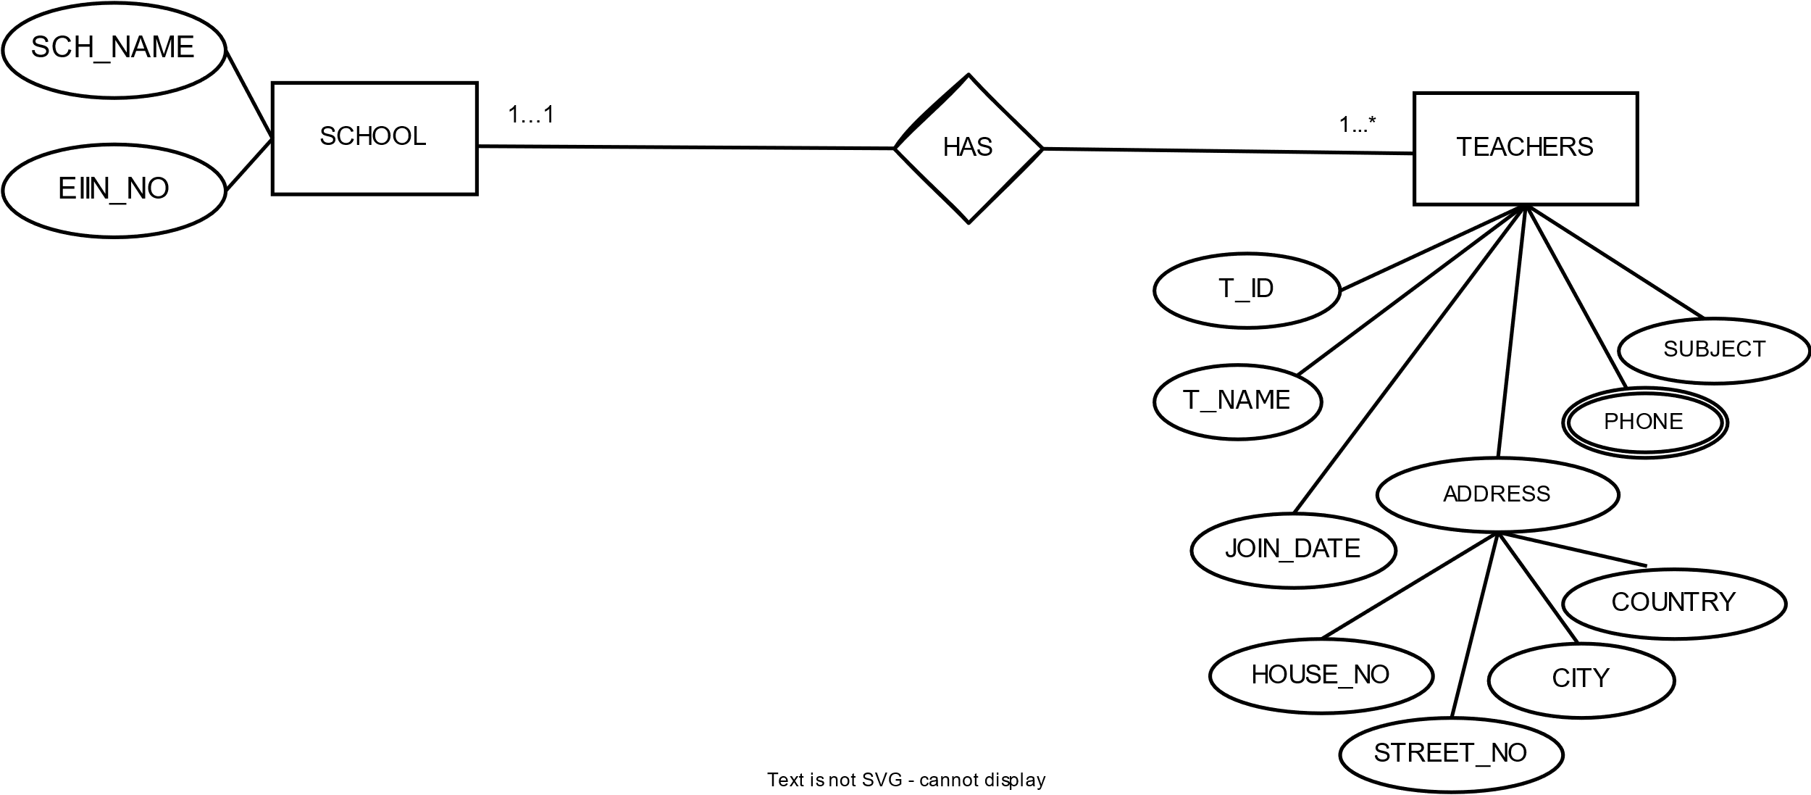

**HAS:**

UNF:

EIIN_NO, SCH_NAME, T_ID, T_NAME, SUBJECT, PHONE, JOIN_DATE, HOUSE_NO, STREET_NO, CITY, COUNTRY

1NF:

PHONE is a multivalued attribute.

EIIN_NO, SCH_NAME, T_ID, T_NAME, SUBJECT, JOIN_DATE, HOUSE_NO, STREET_NO, CITY, COUNTRY

2NF:

1. EIIN_NO, SCH_NAME
2. T_ID, T_NAME, SUBJECT, JOIN_DATE, HOUSE_NO, STREET_NO, CITY, COUNTRY, EIIN_NO, PHONE_ID
3. PHONE_ID, PHONE

3NF:

1. EIIN_NO, SCH_NAME
2. T_ID, T_NAME, SUBJECT, JOIN_DATE, EIIN_NO, PHONE_ID, ADD_ID
3. PHONE_ID, PHONE
4. ADD_ID, HOUSE_NO, STREET_NO, CITY, COUNTRY

**TABLES**

Note: Red marked tables are cancelled out

1. REG_NO, E_DATE, ADD_ID
2. ADD_ID, HOUSE_NO, STREET_NO, CITY, COUNTRY
3. DI_D, D_NAME, REG_NO, ADD_ID, PHONE_ID
4. ADD_ID, HOUSE_NO, STREET_NO, CITY, COUNTRY
5. D_ID, DO_TYPE, DO_AMOUNT, FIRSTD_DATE,
6. PHONE_ID, PHONE
7. REG_NO, E_DATE, ADD_ID
8. ADD_ID, HOUSE_NO, STREET_NO, CITY, COUNTRY
9. DOC_ID, DO_NAME, JOIN_DATE, SALARY, REG_NO, PHONE_ID, ADD_ID
10. ADD_ID, HOUSE_NO, STREET_NO, CITY, COUNTRY
11. PHONE_ID, PHONE
12. REG_NO, E_DATE, ADD_ID
13. ADD_ID, HOUSE_NO, STREET_NO, CITY, COUNTRY
14. EIIN_NO, SCH_NAME, REG_NO
15. REG_NO, E_DATE, ADD_ID
16. ADD_AD, HOUSE_NO, STREET_NO, CITY, COUNTRY
17. O_ID, O_NAME, B-GROUP, GENGER, O_AGE, REG_NO, S_ID, C_ID, DOC_ID, T_ID, A_ID
18. O_ID, C_DATE, COLLECTED_FROM, COLLECTOR
19. M_ID, M_NAME, M_AGE, SALARY, PHONE_ID, ADD_ID
20. ADD_ID, HOUSE_NO, STREET_NO, CITY, COUNTRY
21. PHONE_ID, PHONE
22. C_ID, C_NAME, TOTAL_COLLECTION, SALARY, C_AGE, M_ID, PHONE_ID
23. PHONE_ID, PHONE
24. S_ID, S_NAME, S_AGE, JOIN_DATE, ADD_ID, PHONE_ID
25. S_ID, S_POSITION, SALARY
26. ADD_ID, HOUSE_NO, STREET_NO, CITY, COUNTRY
27. PHONE_ID, PHONE
28. O_ID, O_NAME, B-GROUP, GENGER, O_AGE, S_ID
29. O_I D, C_DATE, COLLECTED_FROM, COLLECTOR
30. C_ID, C_NAME, TOTAL_COLLECTION, SALARY, C_AGE, PHONE_ID
31. PHONE_ID, PHONE
32. O_ID, O_NAME, B_GROUP, GENDER, O_AGE, C_ID
33. O_ID, C_DATE, COLLECTED_FROM, COLLECTOR
34. REG_NO, E_DATE, ADD_ID
35. ADD_ID, HOUSE_NO, STREET_NO, CITY, COUNTRY
36. M_ID, M_NAME, M_AGE, SALARY, REG_NO, PHONE_ID, ADD_ID
37. ADD_ID, HOUSE_NO, STREET_NO, CITY, COUNTRY
38. PHONE_ID, PHONE
39. DOC_ID, DO_NAME, JOIN_DATE, SALARY, ADD_ID, PHONE_ID
40. ADD_ID, HOUSE_NO, STREET_NO, CITY, COUNTRY
41. PHONE_ID, PHONE
42. O_ID, O_NAME, B_GROUP, GENGER, O_AGE, DOC_ID
43. O_I D, C_DATE, COLLECTED_FROM, COLLECTOR
44. M_ID, M_NAME, M_AGE, SALARY, ADD_ID, PHONE_ID
45. ADD_ID, HOUSE_NO, STREET_NO, CITY, COUNTRY
46. PHONE_ID, PHONE
47. S_ID, S_NAME, S_AGE, JOIN_DATE, M_ID, ADD_ID, PHONE_ID
48. S_ID, S_POSITION, SALARY
49. ADD_ID, HOUSE_NO, STREET_NO, CITY, COUNTRY
50. PHONE_ID, PHONE
51. T_ID, T_NAME, SUBJECT, JOIN_DATE, PHONE_ID, ADD_ID
52. PHONE_ID, PHONE
53. ADD_ID, HOUSE_NO, STREET_NO, CITY, COUNTRY
54. O_ID, O_NAME, GENDER, O_AGE, B_GROUP, T_ID
55. O_I D, C_DATE, COLLECTED_FROM, COLLECTOR
56. A_ID, A_NAME, A_AGE, NID_NO, EMAIL, FINANCIAL CONDITION, ADOPTION DATE, PHONE_ID, ADD_ID
57. PHONE_ID, PHONE
58. ADD_ID, HOUSE_NO, STREET_NO, CITY, COUNTRY
59. O_ID, O_NAME, GENDER, AGE, B_GROUP, A_ID
60. O_I D, C_DATE, COLLECTED_FROM, COLLECTOR
61. EIIN_NO, SCH_NAME
62. T_ID, T_NAME, SUBJECT, JOIN_DATE, EIIN_NO, PHONE_ID, ADD_ID
63. PHONE_ID, PHONE
64. ADD_ID, HOUSE_NO, STREET_NO, CITY, COUNTRY

**FINAL TABLES:**

1. PHONE_ID, PHONE
2. ADD_ID, HOUSE_NO, STREET_NO, CITY, COUNTRY
3. REG_NO, E_DATE, ADD_ID
4. D_ID, D_NAME, REG_NO, ADD_ID, PHONE_ID
5. D_ID, DO_TYPE, DO_AMOUNT, FIRSTD_DATE
6. DOC_ID, DO_NAME, JOIN_DATE, SALARY, REG_NO, ADD_ID, PHONE_ID
7. EIIN_NO, SCH_NAME, REG_NO
8. C_ID, C_NAME, TOTAL_COLLECTION, SALARY, C_AGE, M_ID, PHONE_ID
9. A_ID, A_NAME, A_AGE, NID_NO, EMAIL, FINANCIAL CONDITION, ADOPTION DATE, ADD_ID, PHONE_ID
10. T_ID, T_NAME, SUBJECT, JOIN_DATE, EIIN_NO, ADD_ID, PHONE_ID
11. S_ID, S_NAME, S_AGE, JOIN_DATE, M_ID, ADD_ID, PHONE_ID
12. S_ID, S_POSITION, SALARY
13. O_ID, O_NAME, B-GROUP, GENGER, O_AGE, REG_NO, C_ID, DOC_ID, A_ID, T_ID, S_ID
14. O_ID, C_DATE, COLLECTED_FROM, COLLECTOR
15. M_ID, M_NAME, M_AGE, SALARY, REG_NO, ADD_ID, PHONE_ID

**TABLE CREATION**

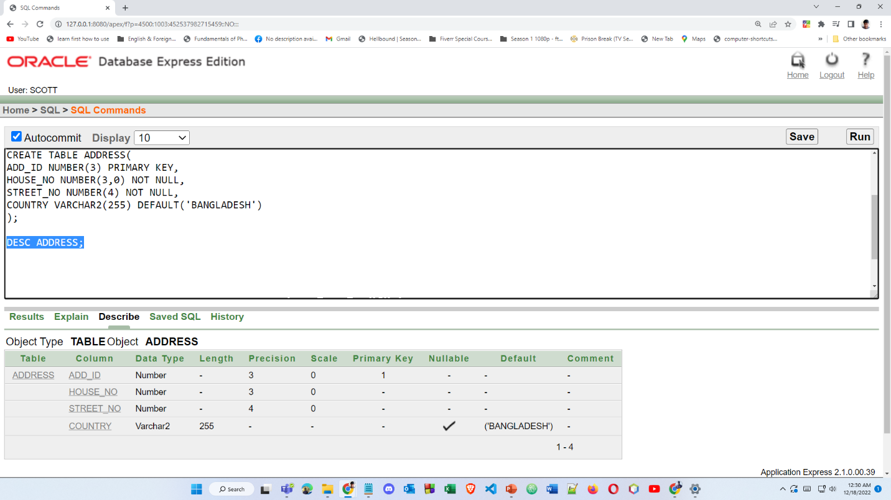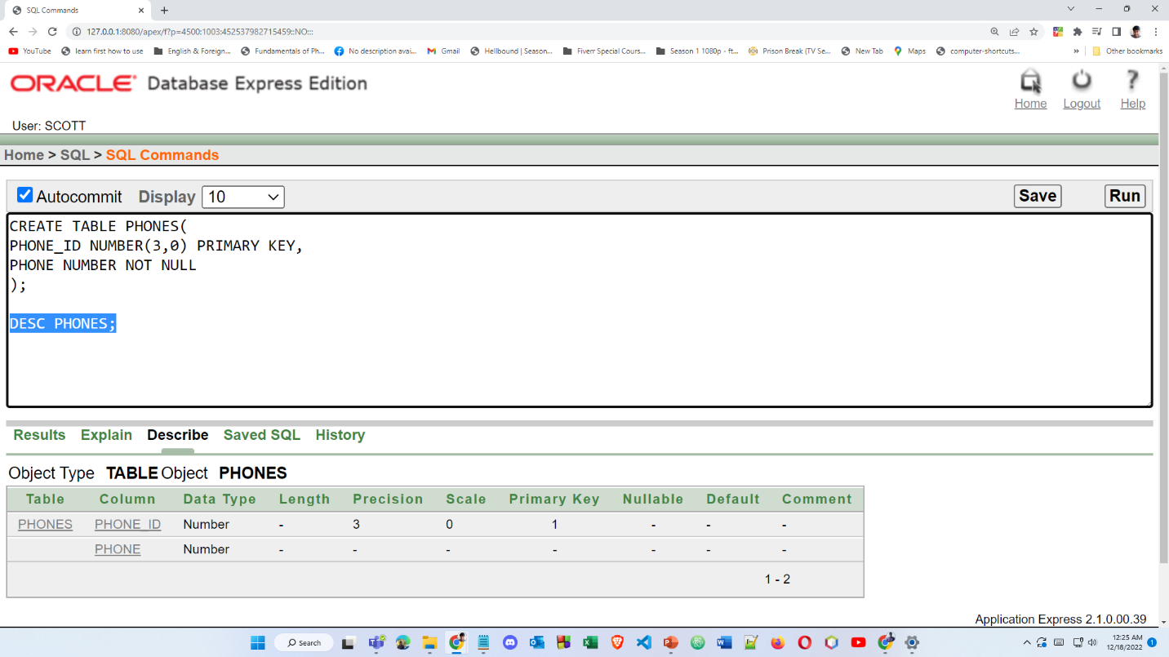

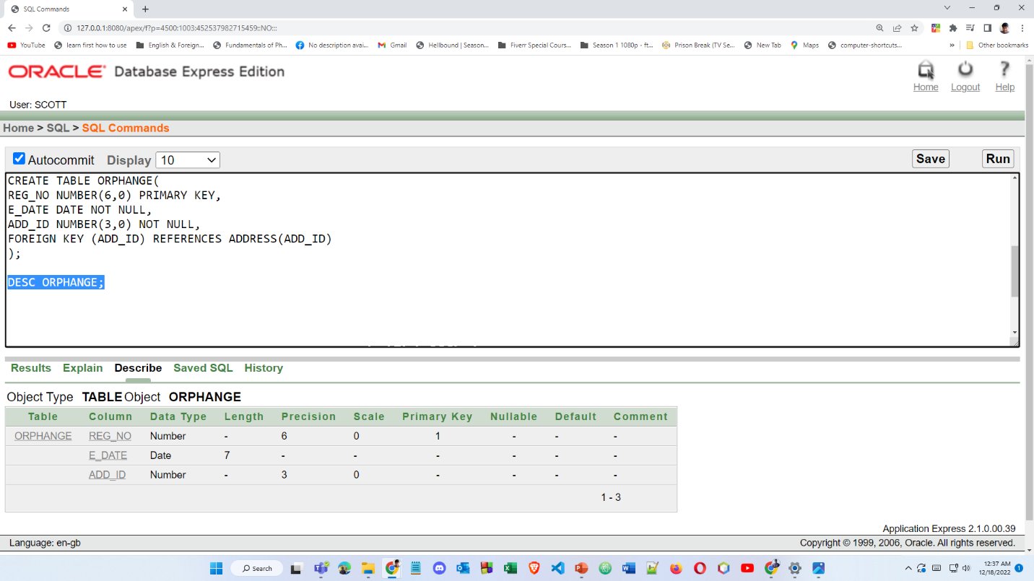

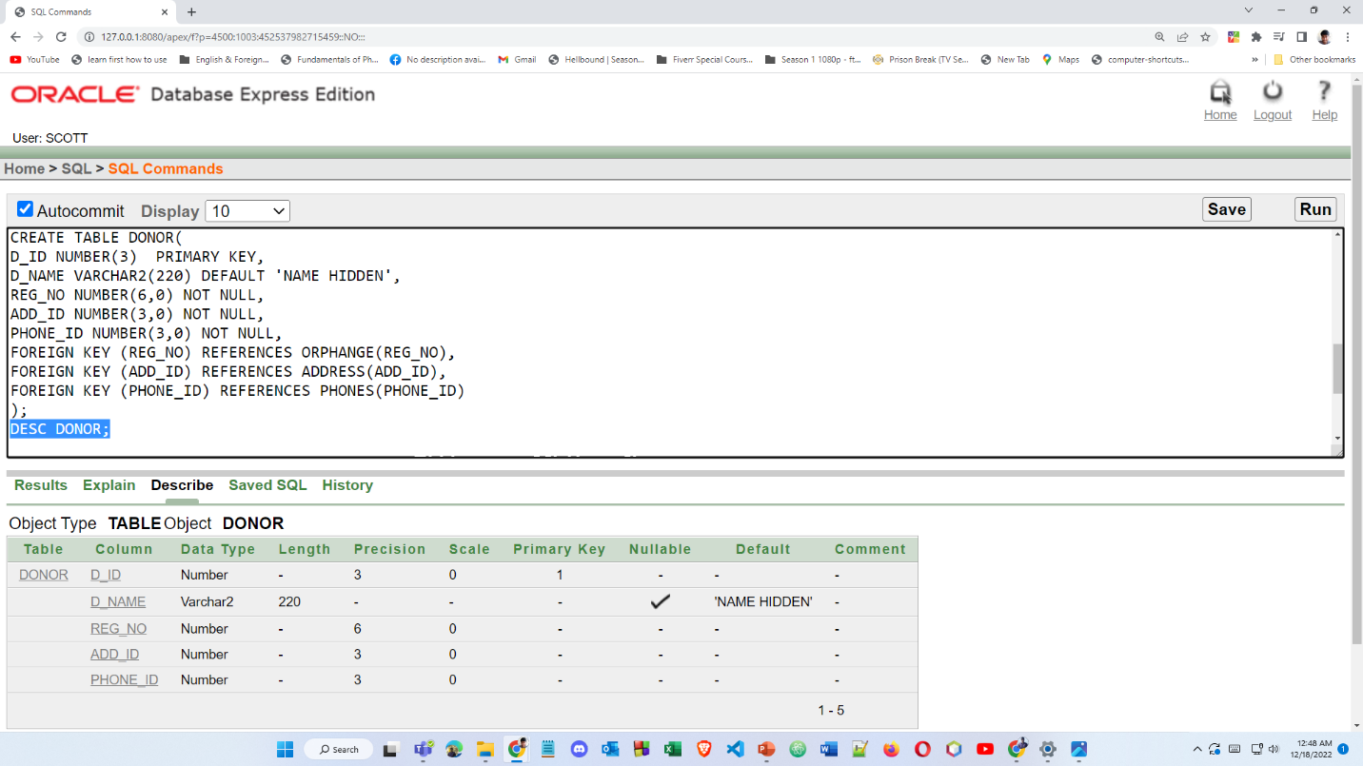

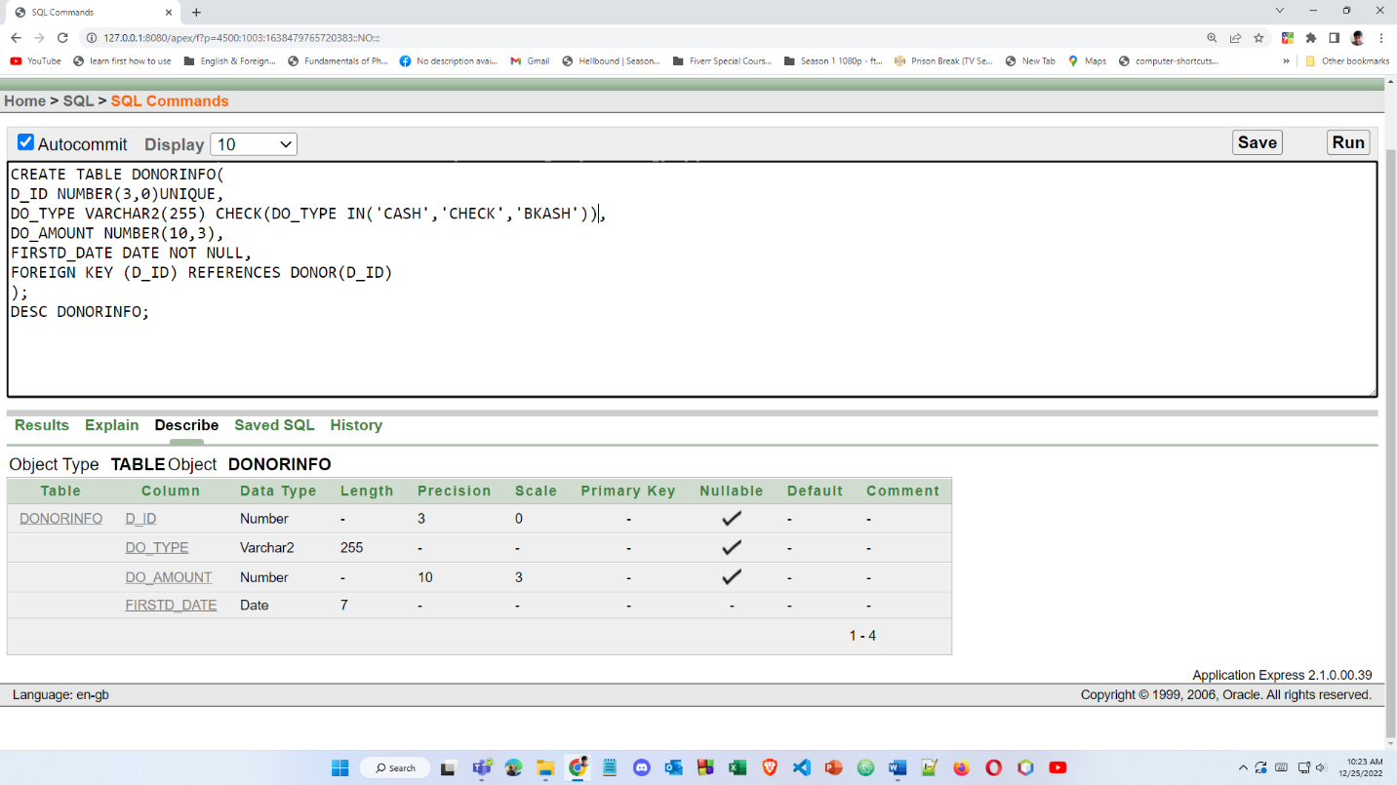

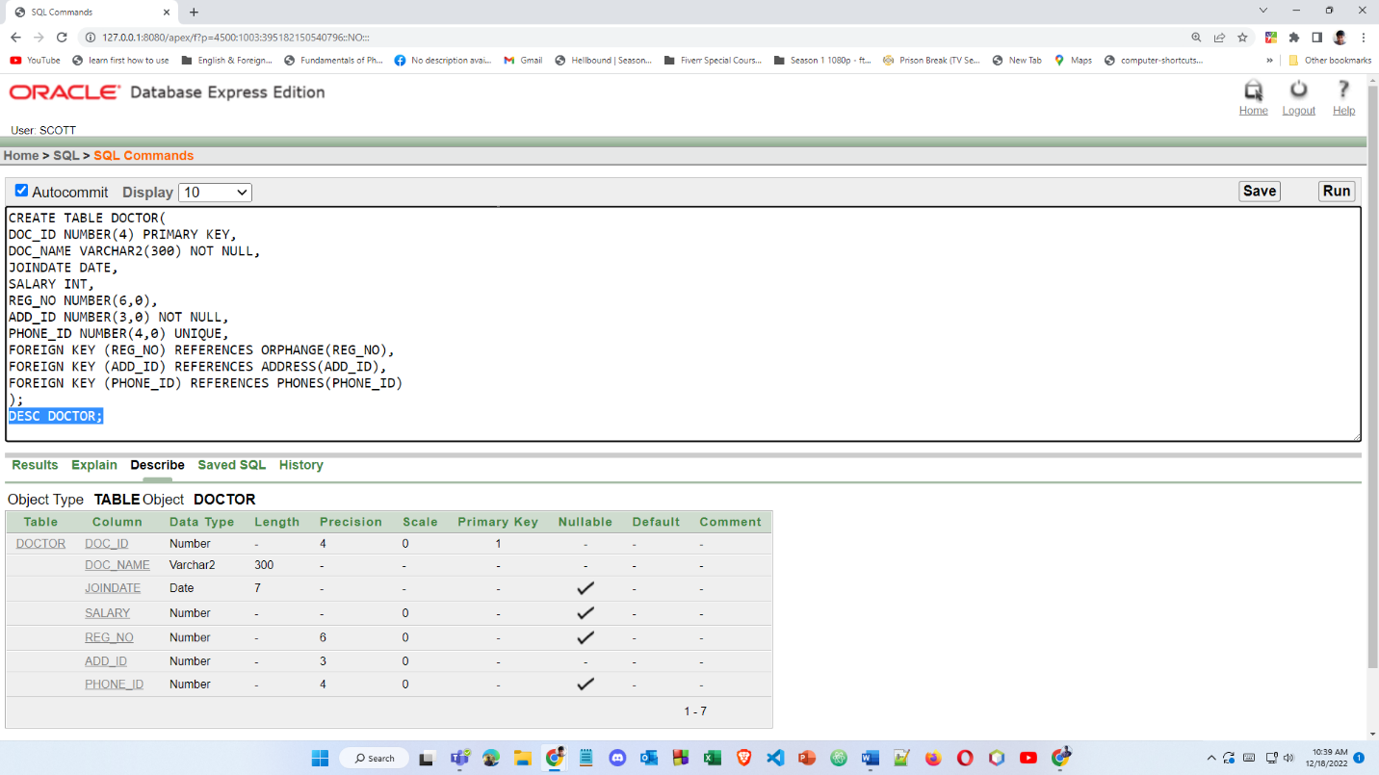

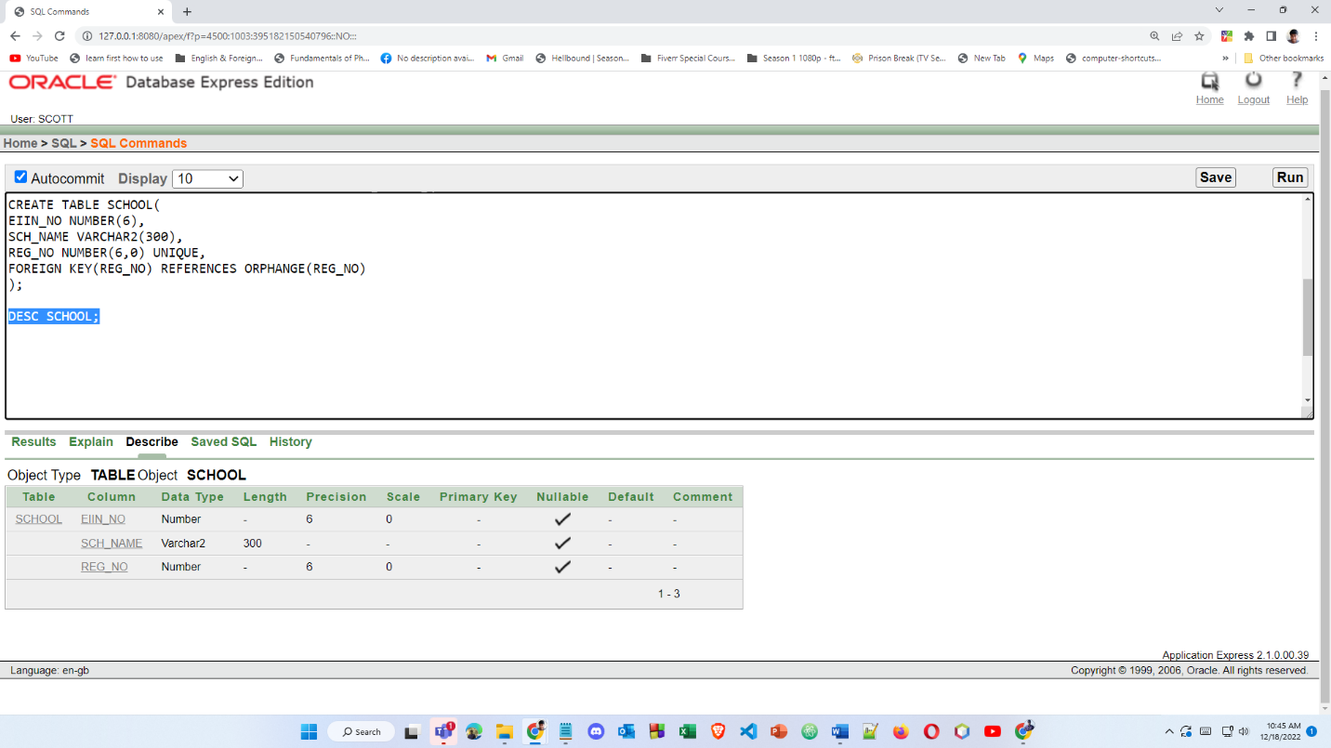

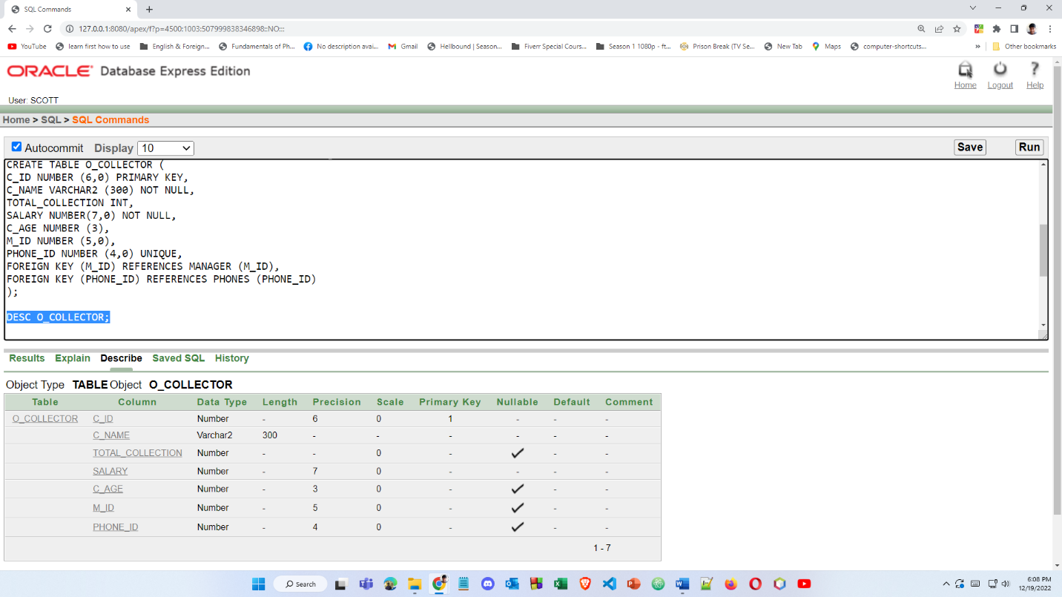

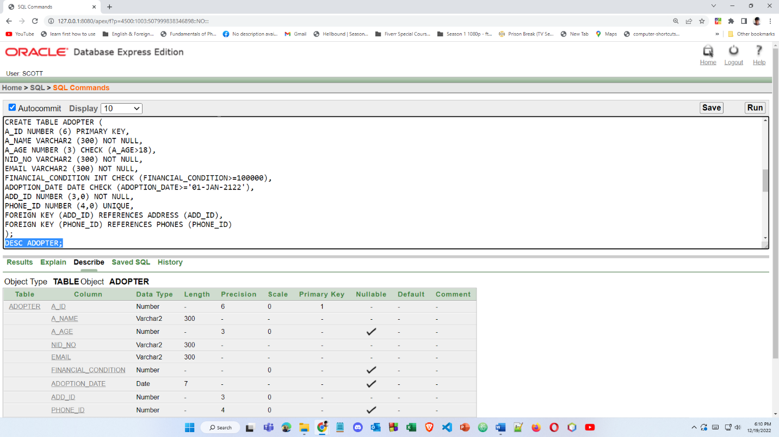

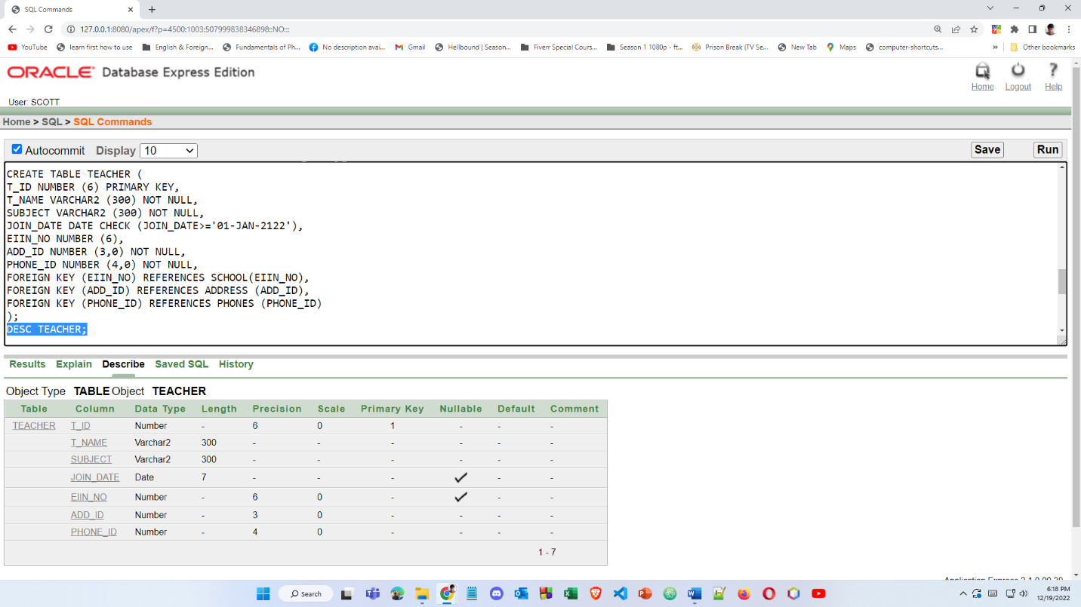

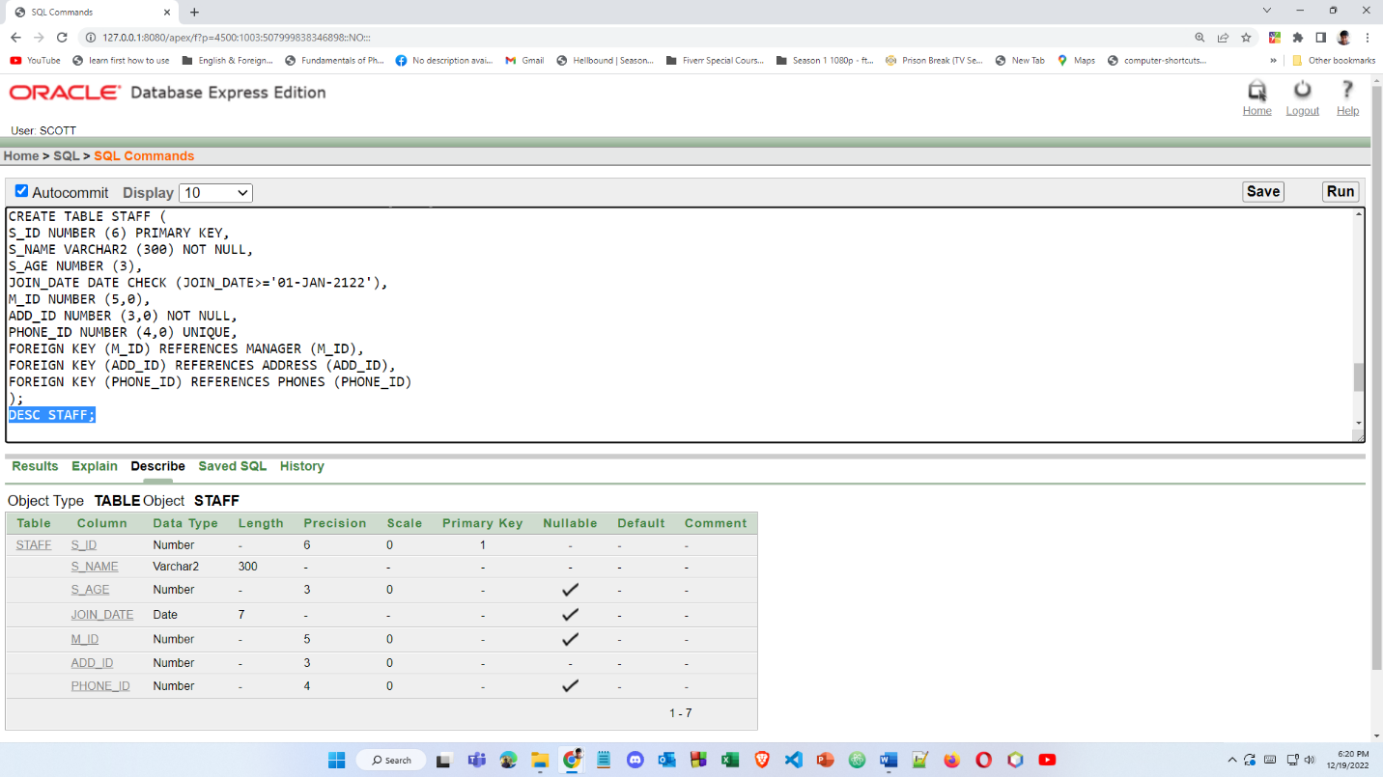

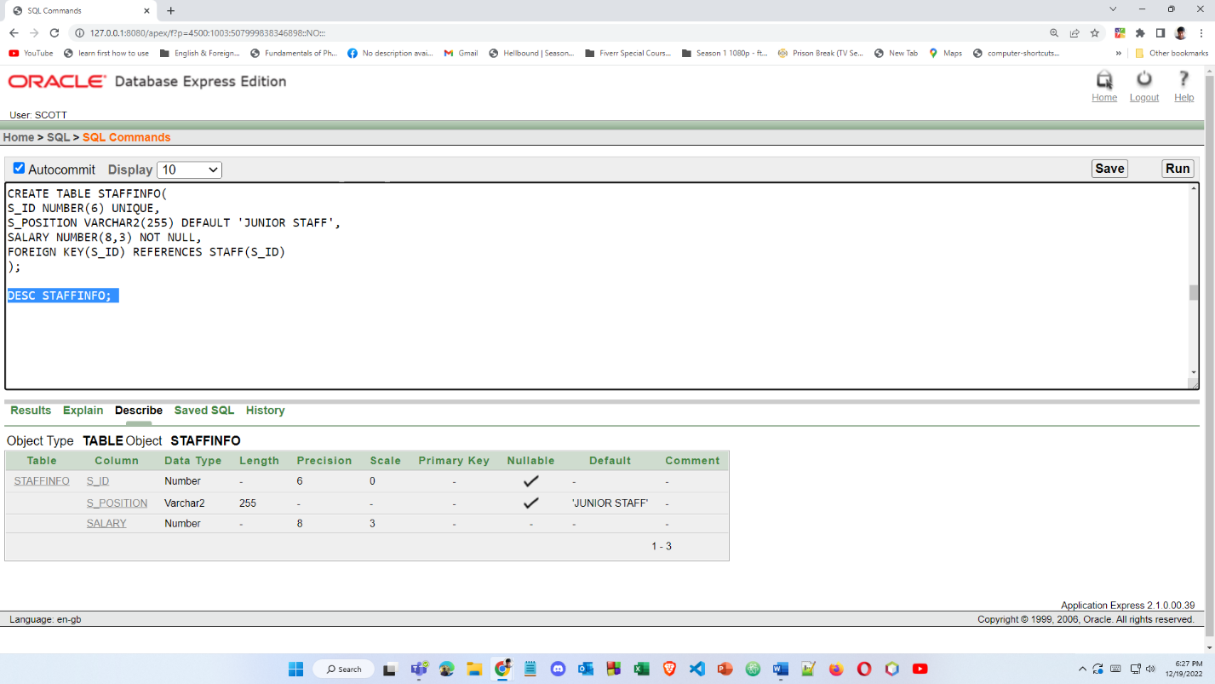

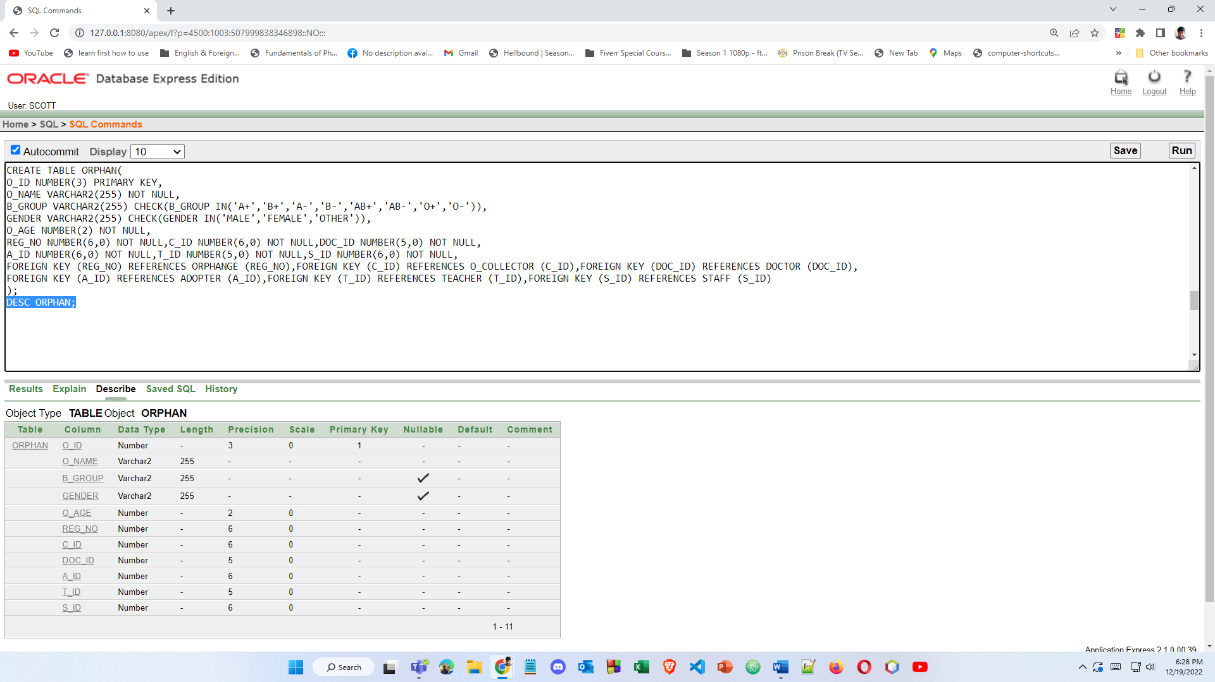

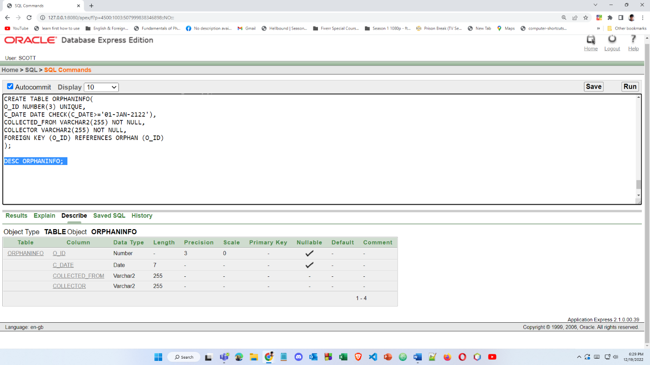

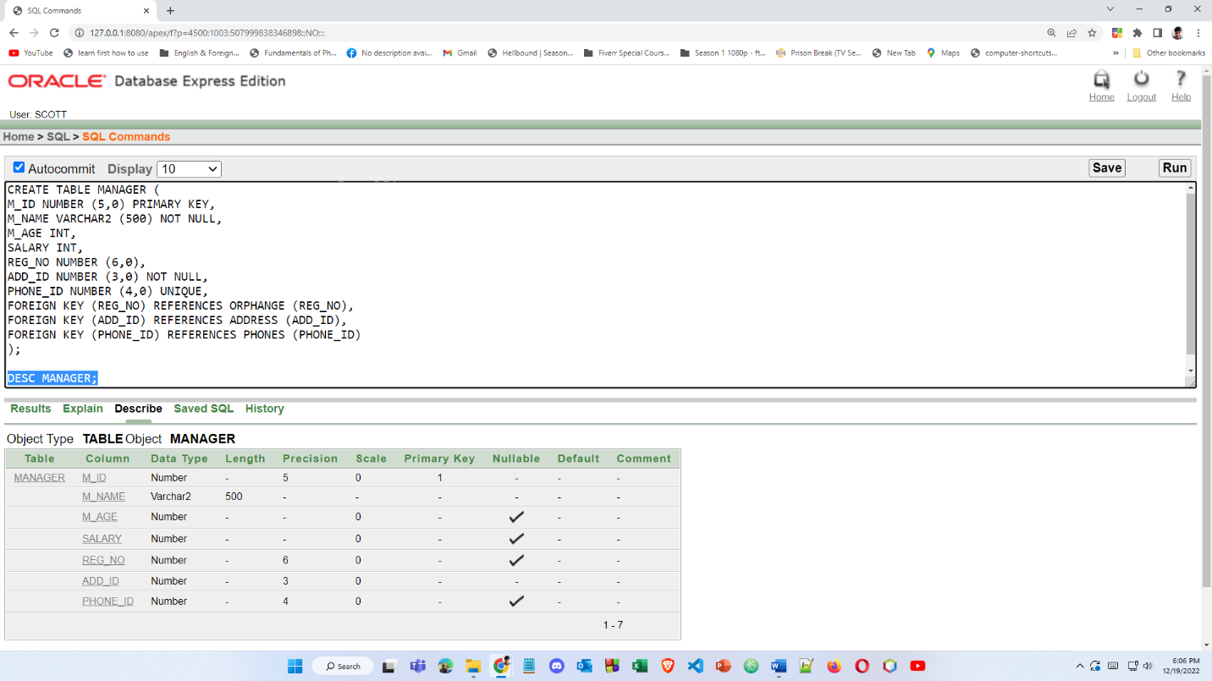

**DATA INSERTION**

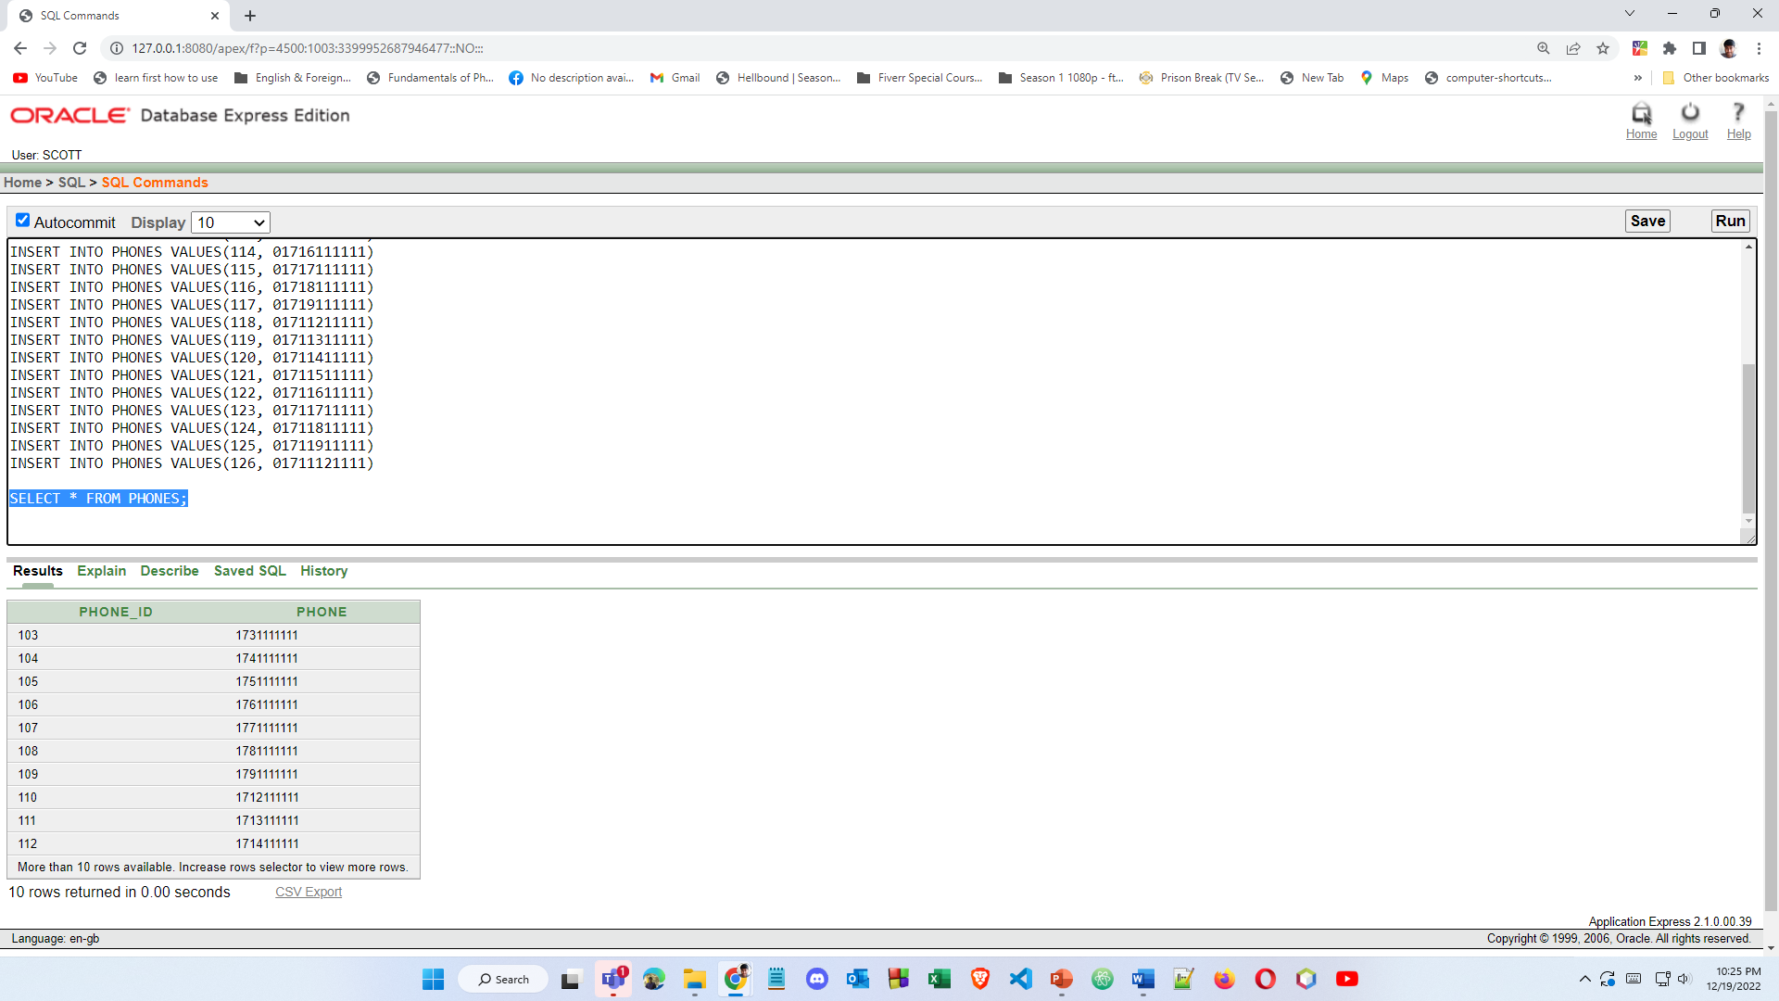

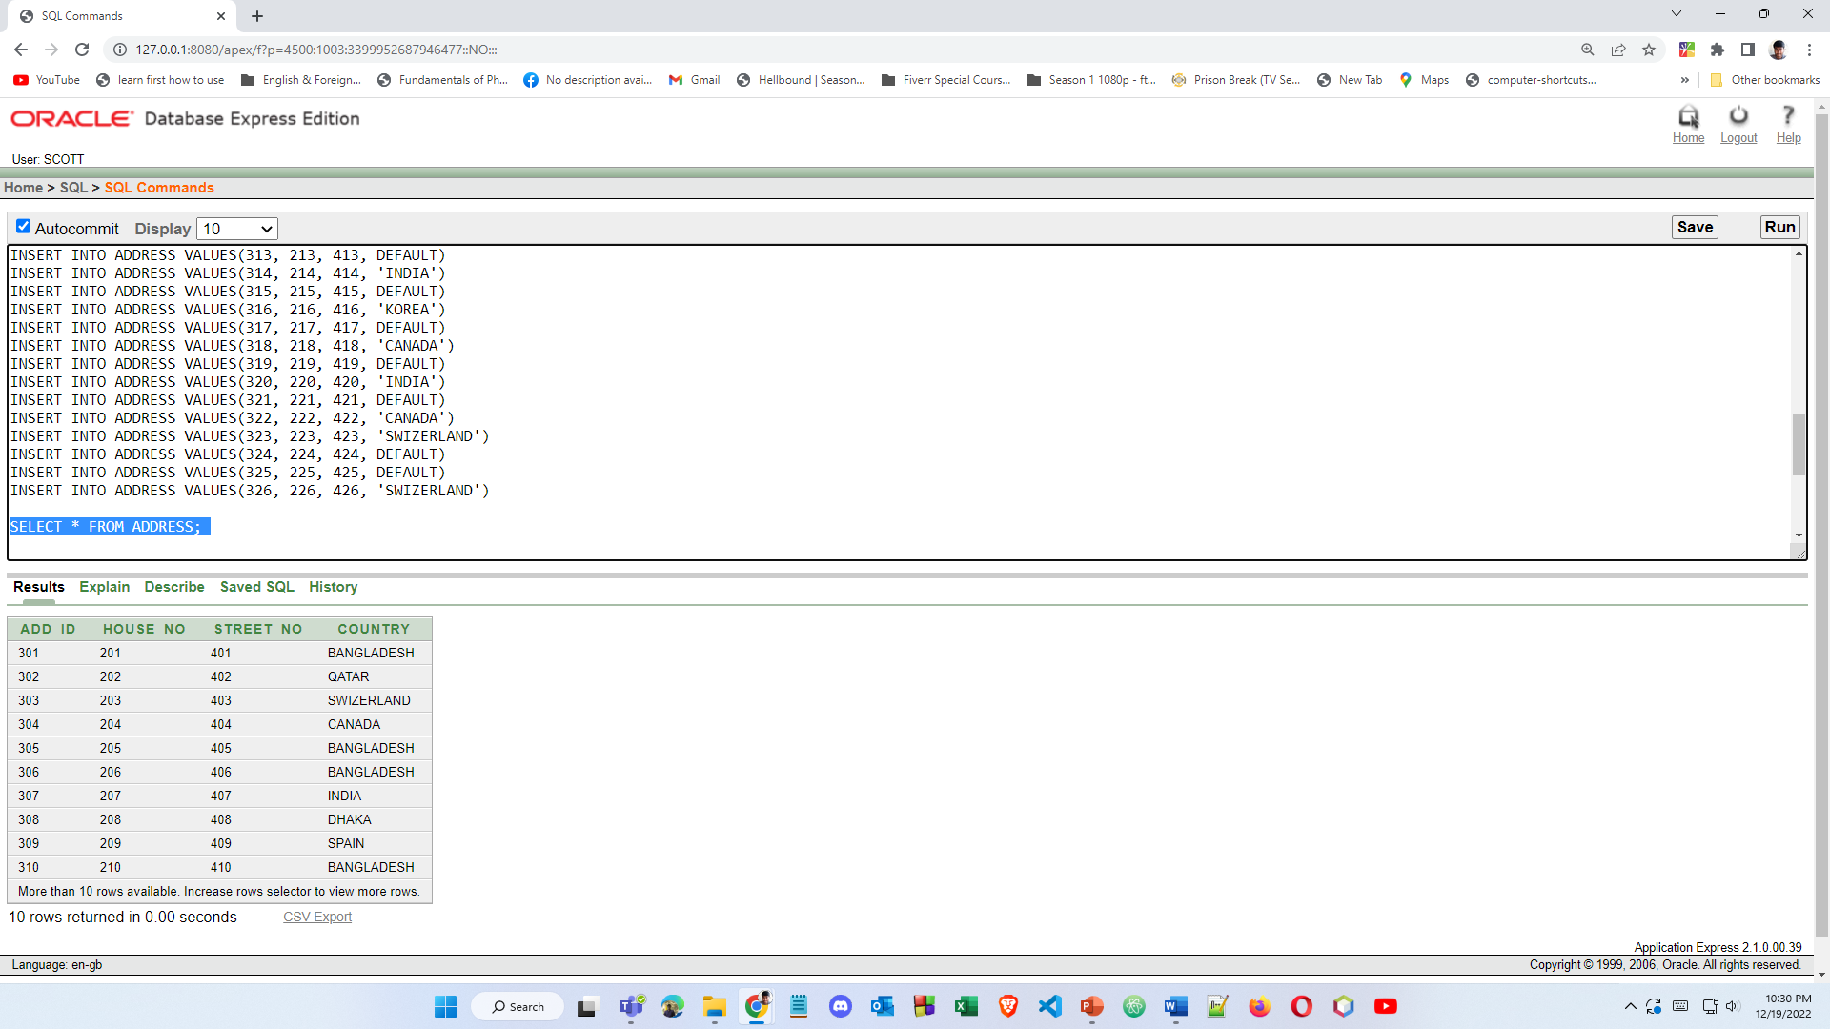

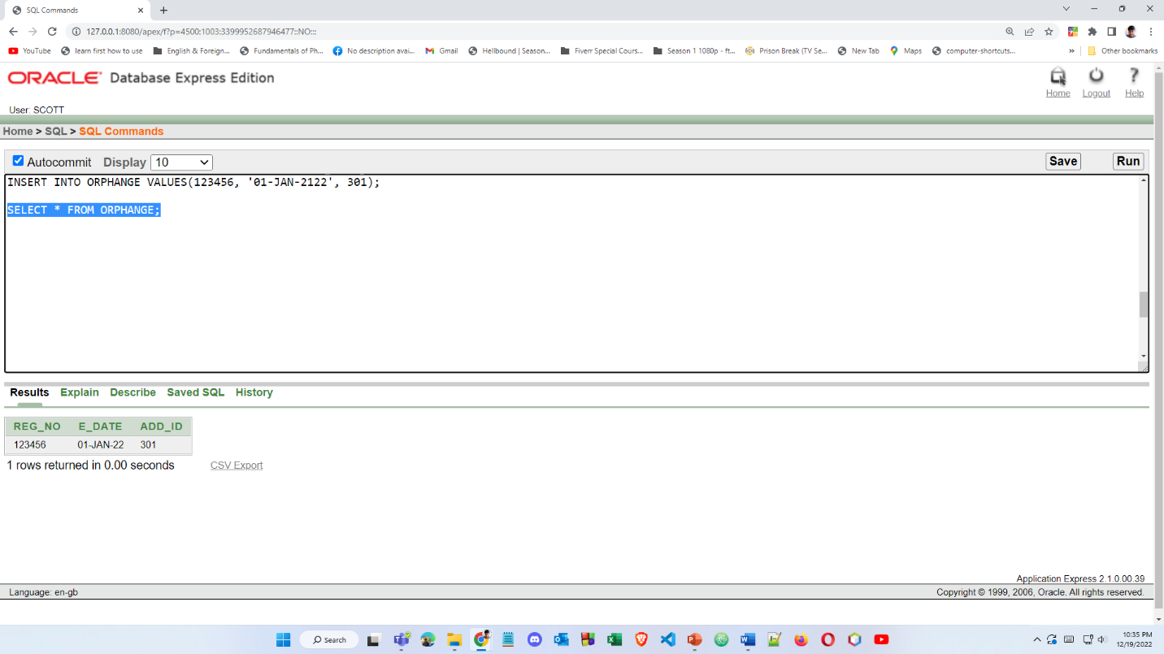

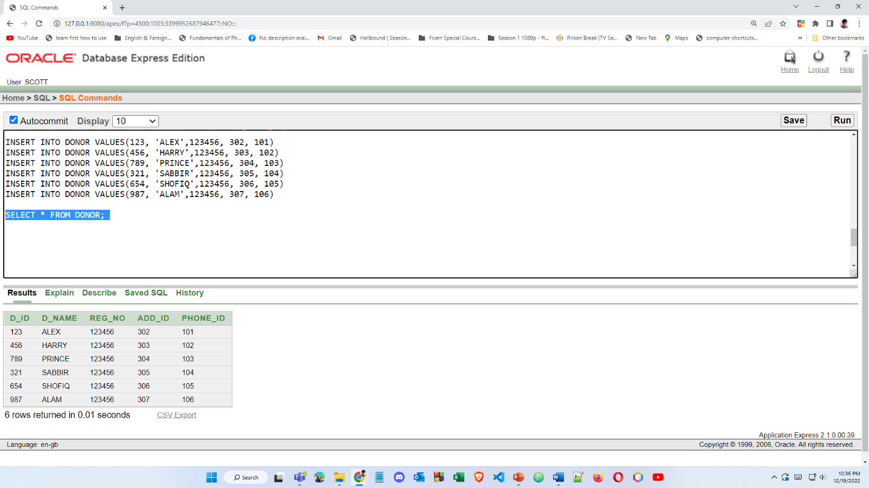

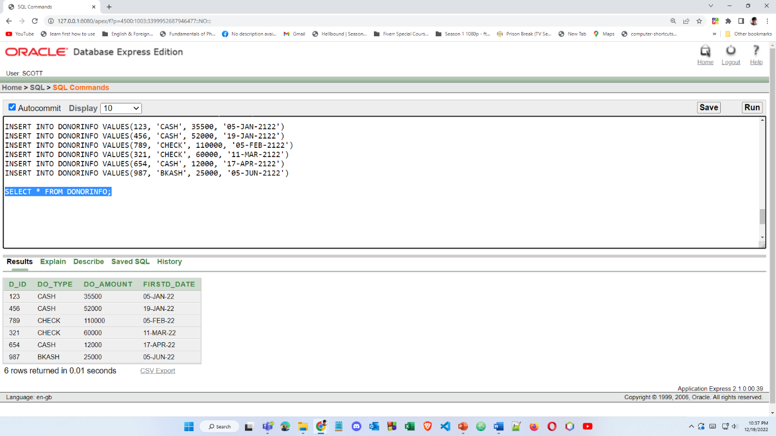

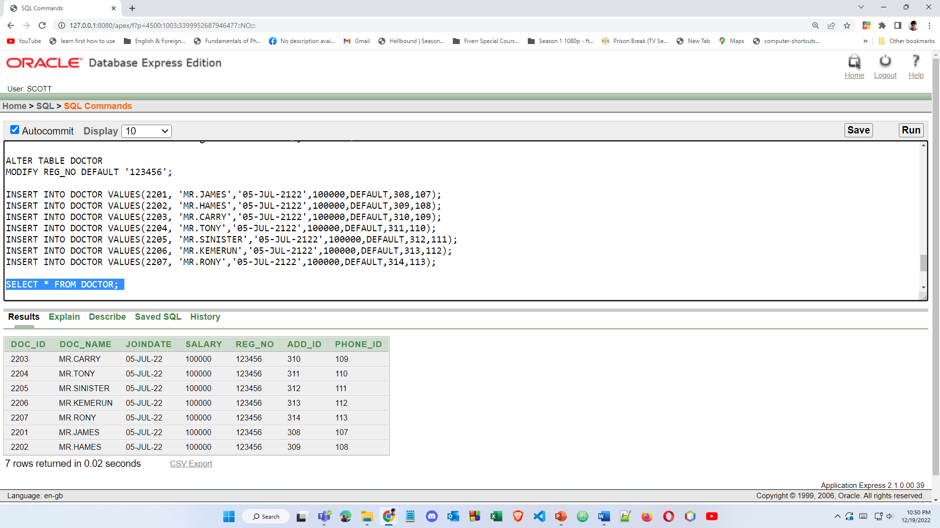

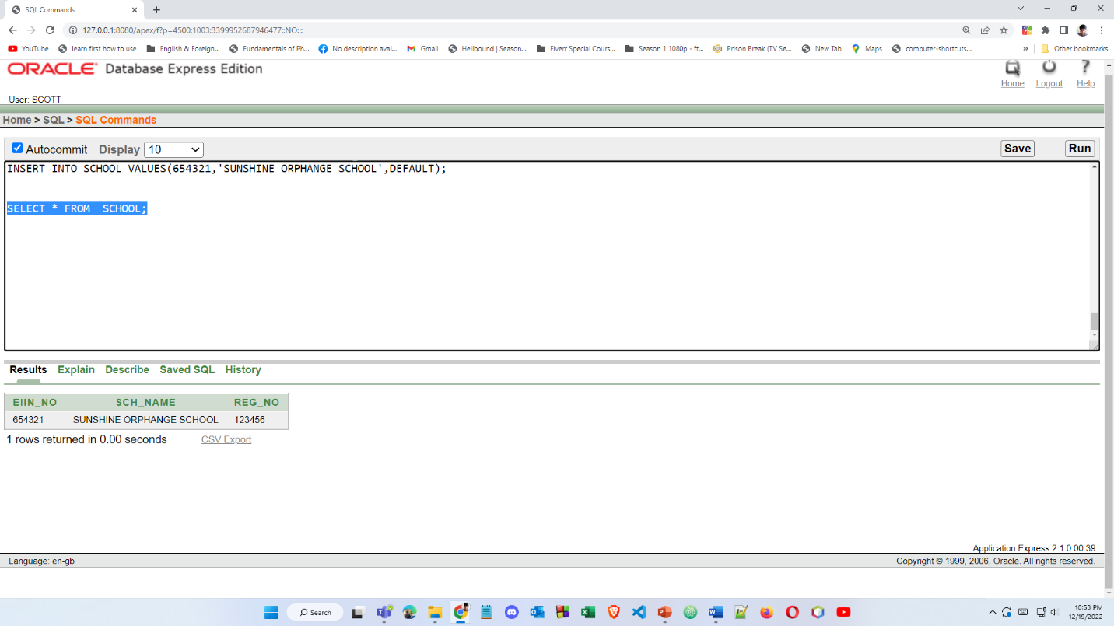

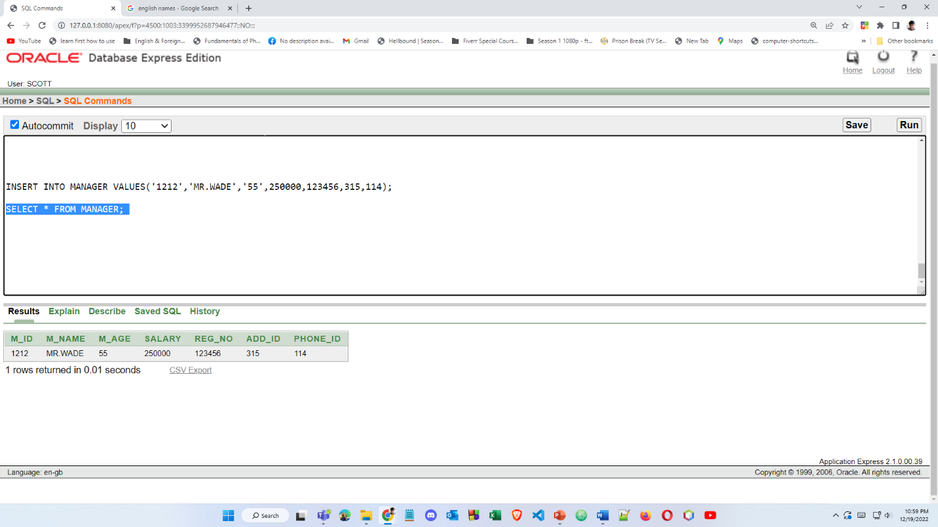

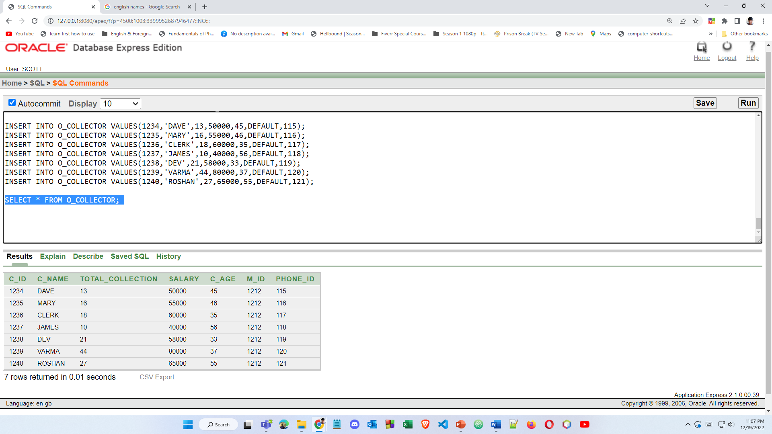

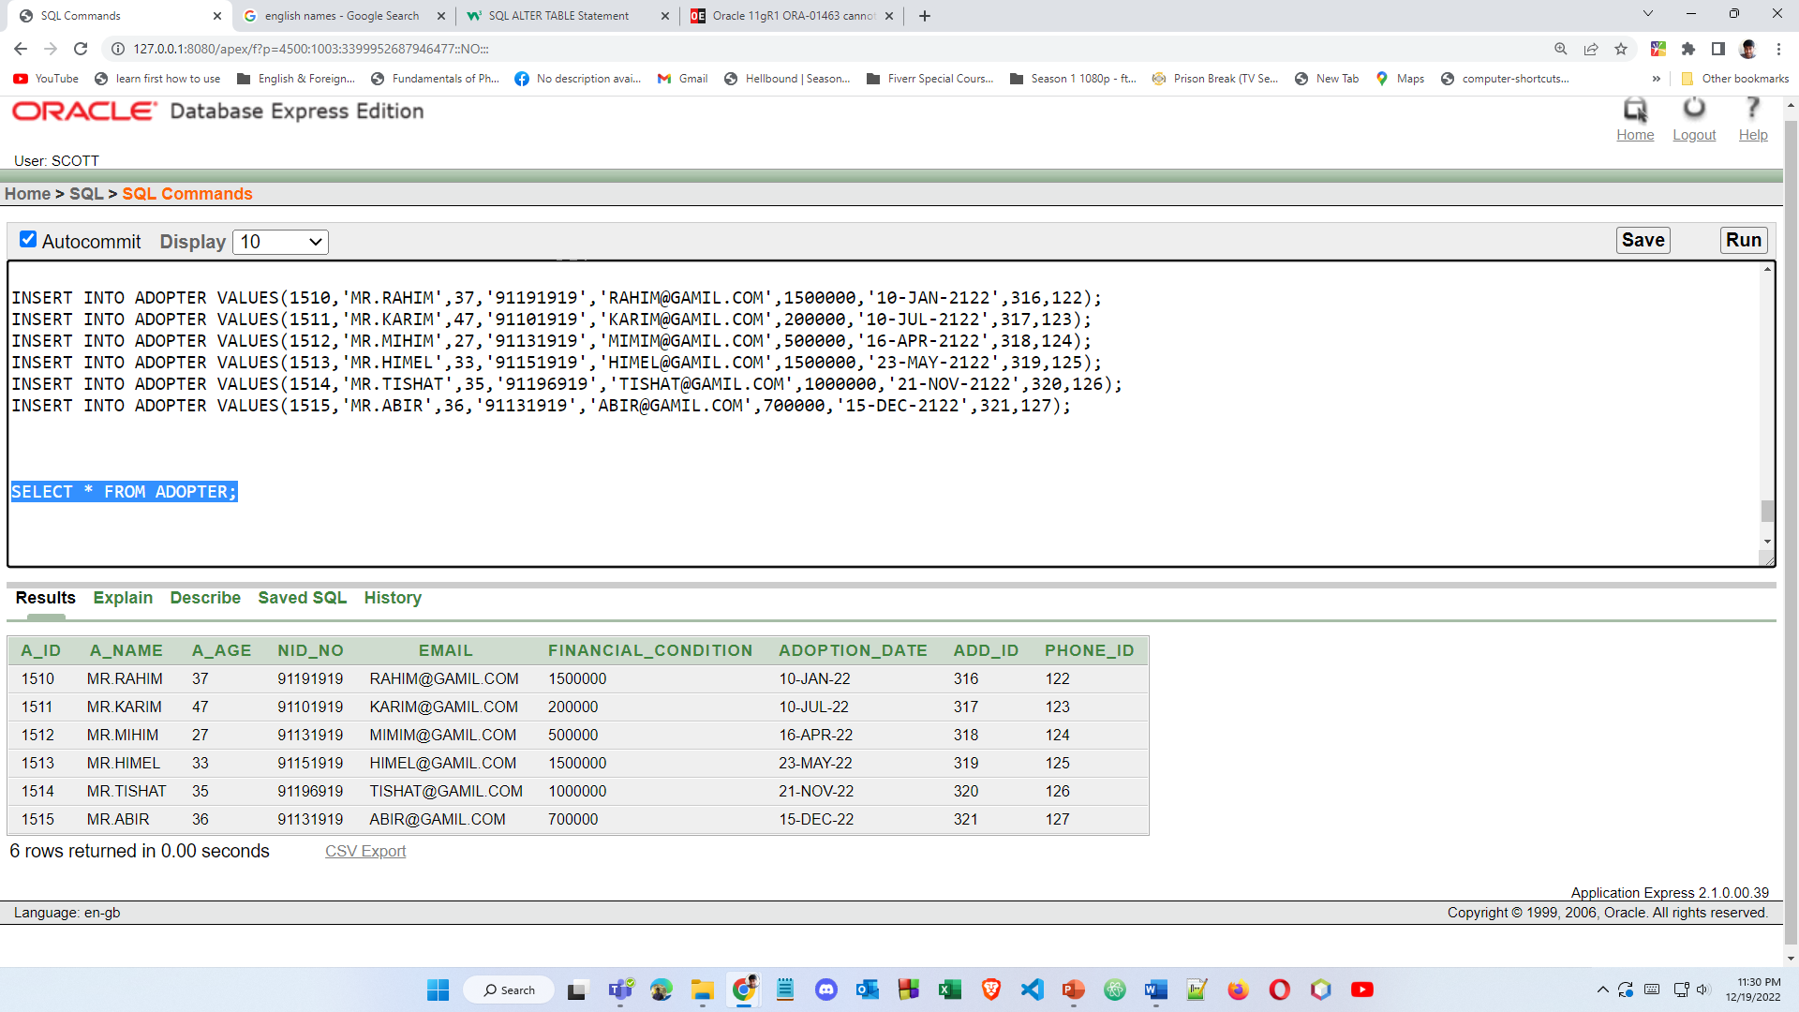

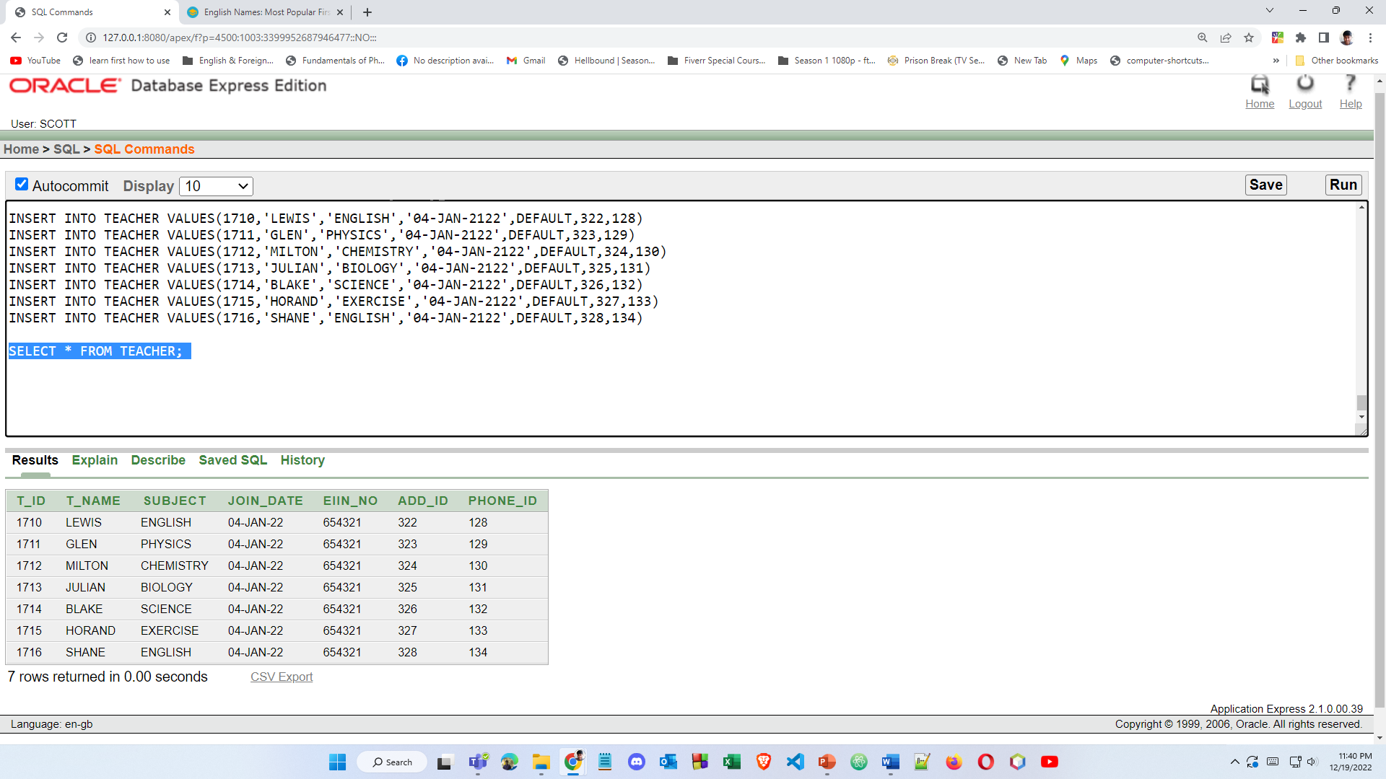

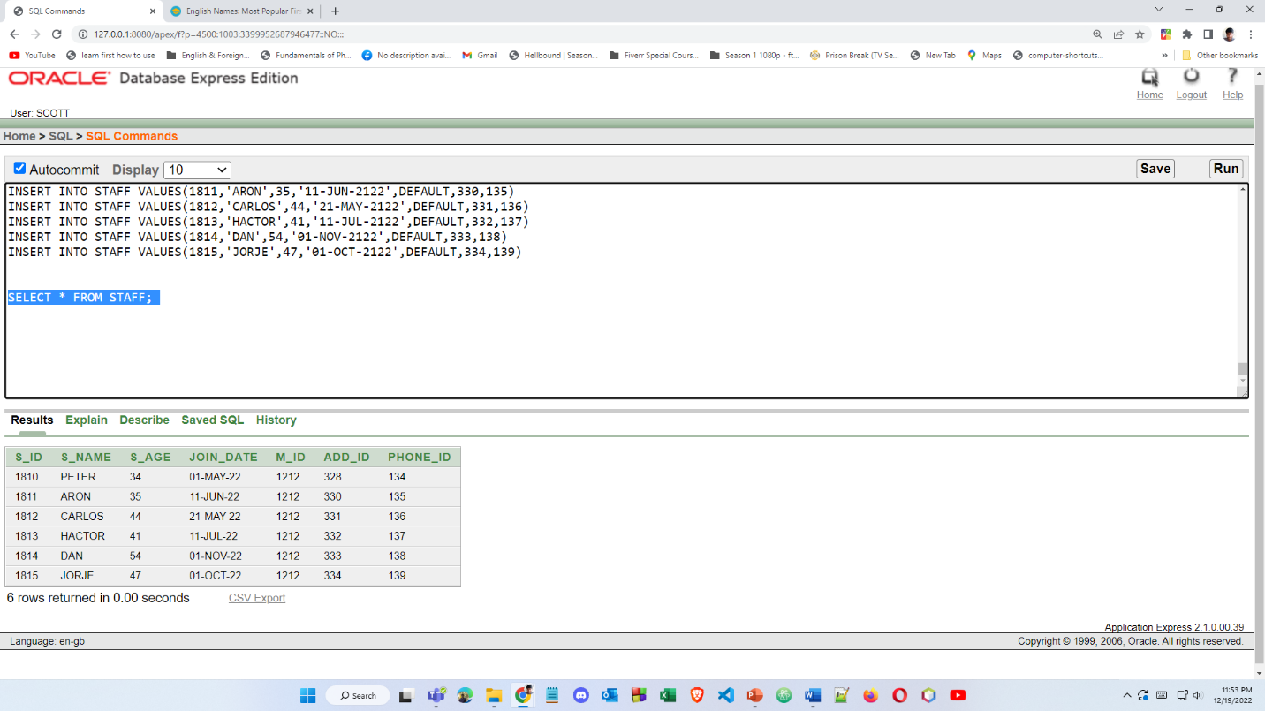

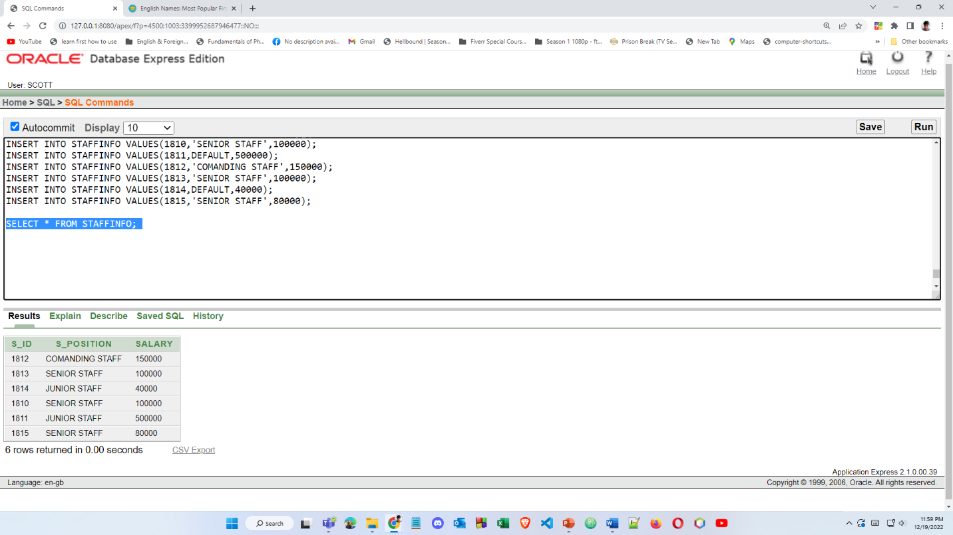

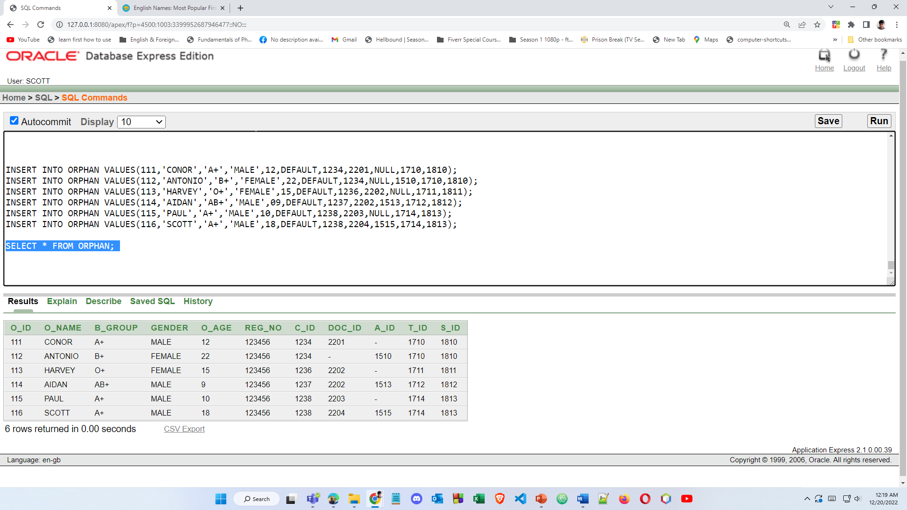

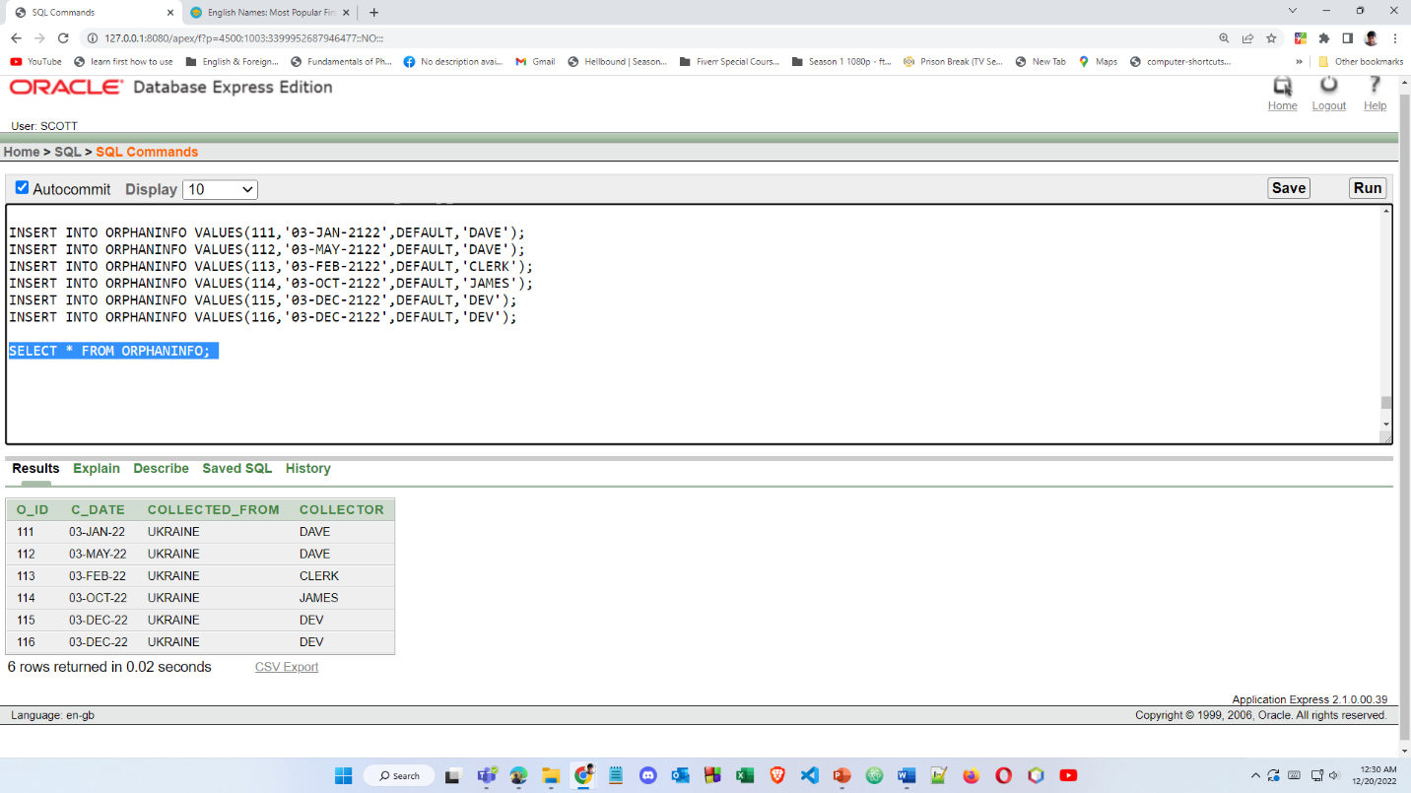

**CONSTRAINTS**

**PHONE**:

|  |  |  |
| --- | --- | --- |
| COLUMN NAME | DATA TYPE | CONSTRAINT |
| PHONE_ID | NUMBER (3,0) | PRIMARY KEY |
| PHONE | NUMBER | NOT NULL |

**ADDRESS**:

|  |  |  |
| --- | --- | --- |
| COLUMN NAME | DATA TYPE | CONSTRAINT |
| ADD_ID | NUMBER (3) | PRIMARY KEY |
| HOUSE_NO | NUMBER (3,0) | NOT NULL |
| STREET_NO | NUMBER (4) | NOT NULL |
| COUNTRY | VARCHAR2(255) | DEFAULT ‘BANGLADESH’ |

**ORPHANAGE**:

|  |  |  |
| --- | --- | --- |
| COLUMN NAME | DATA TYPE | CONSTRAINT |
| REG_NO | NUMBER (6,0) | PRIMARY KEY |
| E_DATE | DATE | NOT NULL |
| ADD_ID | NUMBER (3,0) | FOREIGN KEY FROM ‘ADDRESS’ TABLE |

**DONOR**:

|  |  |  |
| --- | --- | --- |
| COLUMN NAME | DATA TYPE | CONSTRAINT |
| D_ID | NUMBER (3) | PRIMARY KEY |
| D_NAME | VARCHAR2(220) | DEFAULT ‘NAME HIDDEN’ |
| REG_NO | NUMBER (6,0) | FOREIGN KEY FROM ‘ORPHANGE’ TABLE |
| ADD_ID | NUMBER (3,0) | FOREIGN KEY FROM ‘ADDRESS’ TABLE |
| PHONE_ID | NUMBER (3,0) | FOREIGN KEY FROM ‘PHONES’ TABLE |

**DONORINFO**:

|  |  |  |
| --- | --- | --- |
| COLUMN NAME | DATA TYPE | CONSTRAINT |
| D_ID | NUMBER (3,0) | FOREIGN KEY FROM ‘DONOR’ TABLE |
| DO_TYPE | VARCHAR2(255) | ONLY ‘CASH’,’CHECK’, ‘BKASH’ ALLOWED |
| DO_AMOUNT | NUMBER (10,3) | NOT NULL; |
| FIRST_DATE | DATE | NOTNULL |

**DOCTOR**:

|  |  |  |
| --- | --- | --- |
| COLUMN NAME | DATA TYPE | CONSTRAINT |
| DOC_ID | NUMBER (4) | PRIMARY KEY |
| DOC_NAME | VARCHAR2 (300) |  |
| JOINDATE | DATE |  |
| SALARY | INT |  |
| REG_NO | NUMBER (6,0) | DEFAULT ‘123456’ |
| ADD_ID | NUMBER (3,0) | FOREIGN KEY FROM ‘ADDRESS’ TABLE |
| PHONE_ID | NUMBER (4,0) | FOREIGN KEY FROM ‘PHONES’ TABLE |

**SCHOOL**:

|  |  |  |
| --- | --- | --- |
| COLUMN NAME | DATA TYPE | CONSTRAINT |
| EIIN_NO | NUMBER (6) | PRIMARY KEY |
| SCH_NAME | VARCHAR2 (300) |  |
| REG_NO | NUMBER (6,0) | FOREIGN KEY FROM ‘ORPHANGE’ TABLE |

**O_COLLECTOR**:

|  |  |  |
| --- | --- | --- |
| COLUMN NAME | DATA TYPE | CONSTRAINT |
| C_ID | NUMBER (6,0) | PRIMARY KEY |
| C_NAME | VARCHAR2 (300) | NOT NULL |
| TOTAL_COLLECTION | INT |  |
| SALARY | NUMBER (7,0) | NOT NULL |
| C_AGE | NUMBER (3) |  |
| M_ID | NUMBER (5,0) | FOREIGN KEY FROM ‘MANAGER’ TABLE |
| PHONE_ID | NUMBER (4,0) | FOREIGN KEY FROM ‘PHONES’ TABLE |

**ADOPTER**:

|  |  |  |
| --- | --- | --- |
| COLUMN NAME | DATA TYPE | CONSTRAINT |
| A_ID | NUMBER (6) | PRIMARY KEY |
| A_NAME | VARCHAR2(300) | NOT NULL |
| A_AGE | NUMBER (3) | CHECK A_AGE > 18 |
| NID_NO | VARCHAR2(300) | NOT NULL |
| EMAIL | VARCHAR2(300) | NOT NULL |
| FINANCIAL_CONDITION | INT | CHECK FINANCIAL_CONDITION > 100000 |
| ADOPTION_DATE | DATE | ADOPTION_DATE > ’01-JAN-2122’ |
| ADD_ID | NUMBER (3,0) | FOREIGN KEY FROM ‘ADDRESS’ TABLE |
| PHONE_ID | NUMBER (4,0) | FOREIGN KEY FROM ‘PHONES’ TABLE |

**TEACHER**:

|  |  |  |
| --- | --- | --- |
| COLUMN NAME | DATA TYPE | CONSTRAINT |
| T_ID | NUMBER (6) | PRIMARY KEY |
| T_NAME | VARCHAR2(300) | NOT NULL |
| SUBJECT | VARCHAR2(300) | NOT NULL |
| JOIN_DATE | DATE | CHECK JOIN_DATE >= ’01-JAN-2122’ |
| EIIN_NO | NUMBER (6,0) | FOREIGN KEY FROM ‘SCHOOL’ TABLE |
| ADD_ID | NUMBER (3,0) | FOREIGN KEY FROM ‘ADDRESS’ TABLE |
| PHONE_ID | NUMBER (4,0) | FOREIGN KEY FROM ‘PHONES’ TABLE |

**STAFF**:

|  |  |  |
| --- | --- | --- |
| COLUMN NAME | DATA TYPE | CONSTRAINT |
| S_ID | NUMBER (6) | PRIMARY KEY |
| S_NAME | VARCHAR2 (300) | NOT NULL |
| S_AGE | NUMBER (3) |  |
| JOIN_DATE | DATE | CHECK JOIN_DATE >= ‘-1-JAN-2122’ |
| M_ID | NUMBER (5,0) | FOREIGN KEY FROM ‘MANAGER’ TABLE |
| ADD_ID | NUMBER (3,0) | FOREIGN KEY FROM ‘ADDRESS’ TABLE |
| PHONE_ID | NUMBER (4,0) | FOREIGN KEY FROM ‘PHONES’ TABLE |

**STAFFINFO**:

|  |  |  |
| --- | --- | --- |
| COLUMN NAME | DATA TYPE | CONSTRAINT |
| S_ID | NUMBER (6) | FOREIGN KEY FROM ‘STAFF’ TABLE |
| S_POSITION | VARCHAR2(255) | DEFAULT ‘JUNIOR STAFF’ |
| SALARY | NUMBER (8,3) | NOT NULL |

**ORPHAN**:

|  |  |  |
| --- | --- | --- |
| COLUMN NAME | DATA TYPE | CONSTRAINT |
| O_ID | NUMBER (3) | PRIMARY KEY |
| O_NAME | VARCHAR2 (255) | NOT NULL |
| B_GROUP | VARCHAR2(255) | ONLY A+',' B+', 'A-', 'B-', 'AB+',' AB-', 'O+', 'O-' ALLOWED |
| GENDER | VARCHAR2 (255) | ONLY ‘MALE’, ‘FEMALE’, ‘OTHER’ ALLOWED |
| O_AGE | NUMBER (2) | NOT NULL |
| REG_NO | NUMBER (6,0) | DEFAULT ‘123456’ |
| ADD_ID | NUMBER (3,0) | FOREIGN KEY FROM ‘ADDRESS’ TABLE |
| DOC_ID | NUMBER (5,0) | FOREIGN KEY FROM ‘DOCTOR’ TABLE |
| T_ID | NUMBER (5,0) | FOREIGN KEY FROM ‘TEACHER’ TABLE |
| A_ID | NUMBER (6,0) | FOREIGN KEY FROM ‘ADOPTER’ TABLE |
| S_ID | NUMBER (6,0) | FOREIGN KEY FROM ‘STAFF’ TABLE |

**ORPHANINFO**:

|  |  |  |
| --- | --- | --- |
| COLUMN NAME | DATA TYPE | CONSTRAINT |
| O_ID | NUMBER (3) | FOREIGN KEY FROM ‘ORPHANTABLE’ TABLE |
| C_DATE | DATE | CHECK C_DATE >= ’01-JAN-2122’ |
| COLLECTED_FROM | VARCHAR2 (255) | NOT NULL |
| COLLECTOR | VARCHAR2(255) | NOT NULL |

**MANAGER**:

|  |  |  |
| --- | --- | --- |
| COLUMN NAME | DATA TYPE | CONSTRAINT |
| M_ID | NUMBER (5,0) | PRIMARY KEY |
| M_NAME | VARCHAR2 (500) | NOT NULL |
| M_AGE | NUMBER |  |
| SALARY | NUMBER |  |
| REG_NO | NUMBER (6,0) | DEFAULT ‘123456’ |
| ADD_ID | NUMBER (3,0) | FOREIGN KEY FROM ‘ADDRESS’ TABLE |
| PHONE_ID | NUMBER (4,0) | FOREIGN KEY FROM ‘PHONES’ TABLE |

**QUERY TEST**

**SUBQUERY:**

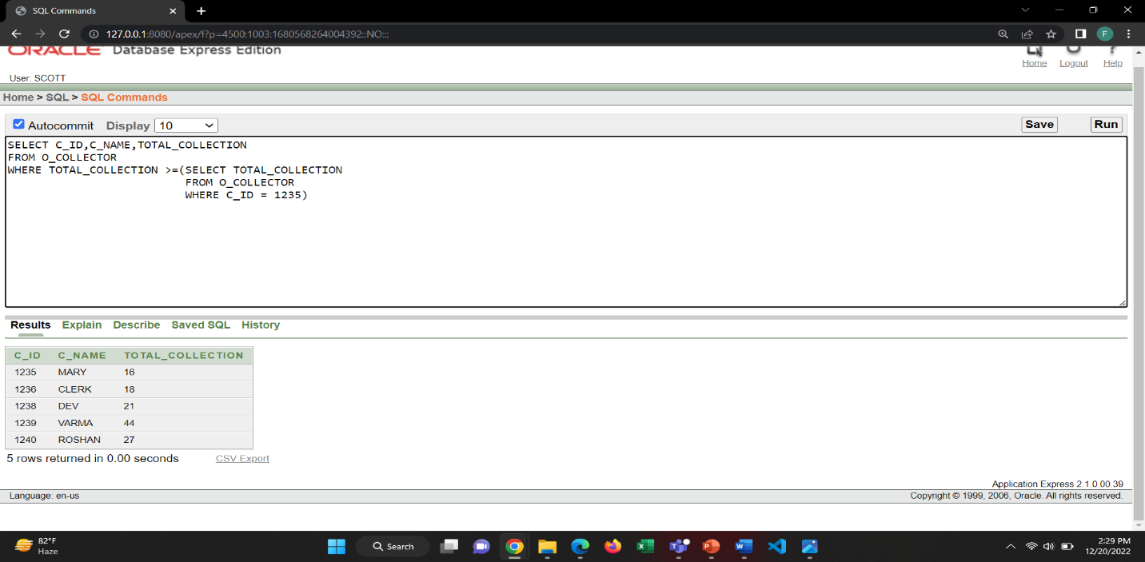1. Show the Collector Name, Collector ID, Total Collection of those collector, whose collection is greater than the collector with ID = 1235

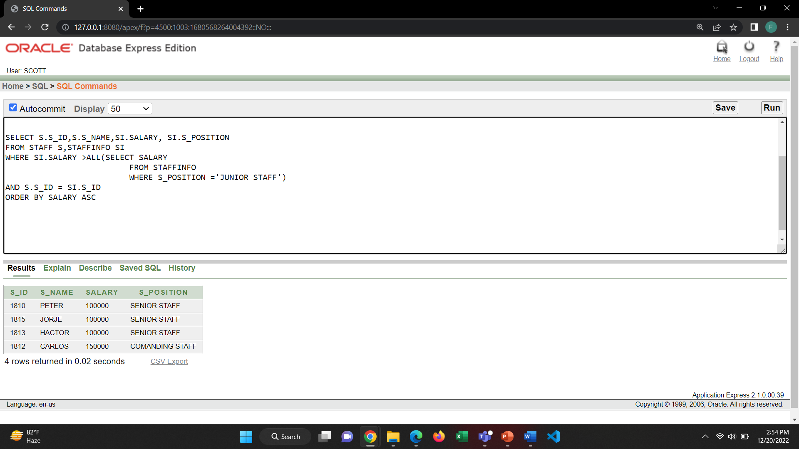2. Show the Staff ID, Name, Salary and position of those staffs who earn a salary that is higher than the salary of junior staff order by salary Ascending.

**JOINING**:

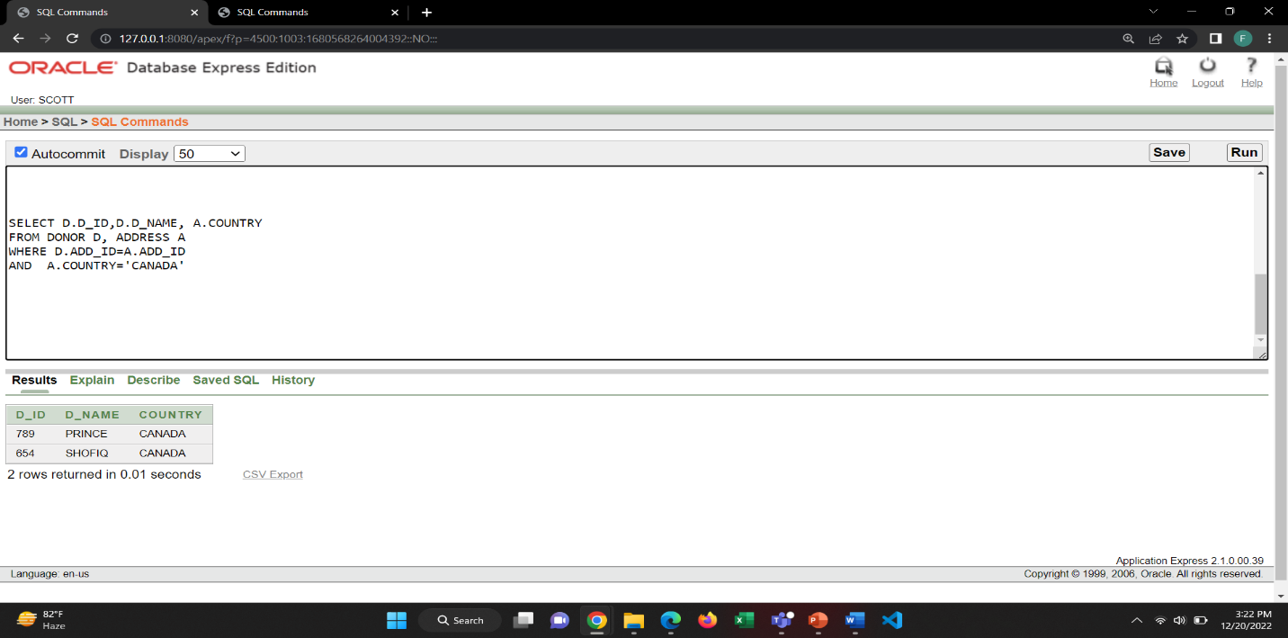1. Show the Donor ID, Donor name those are from the country CANADA.

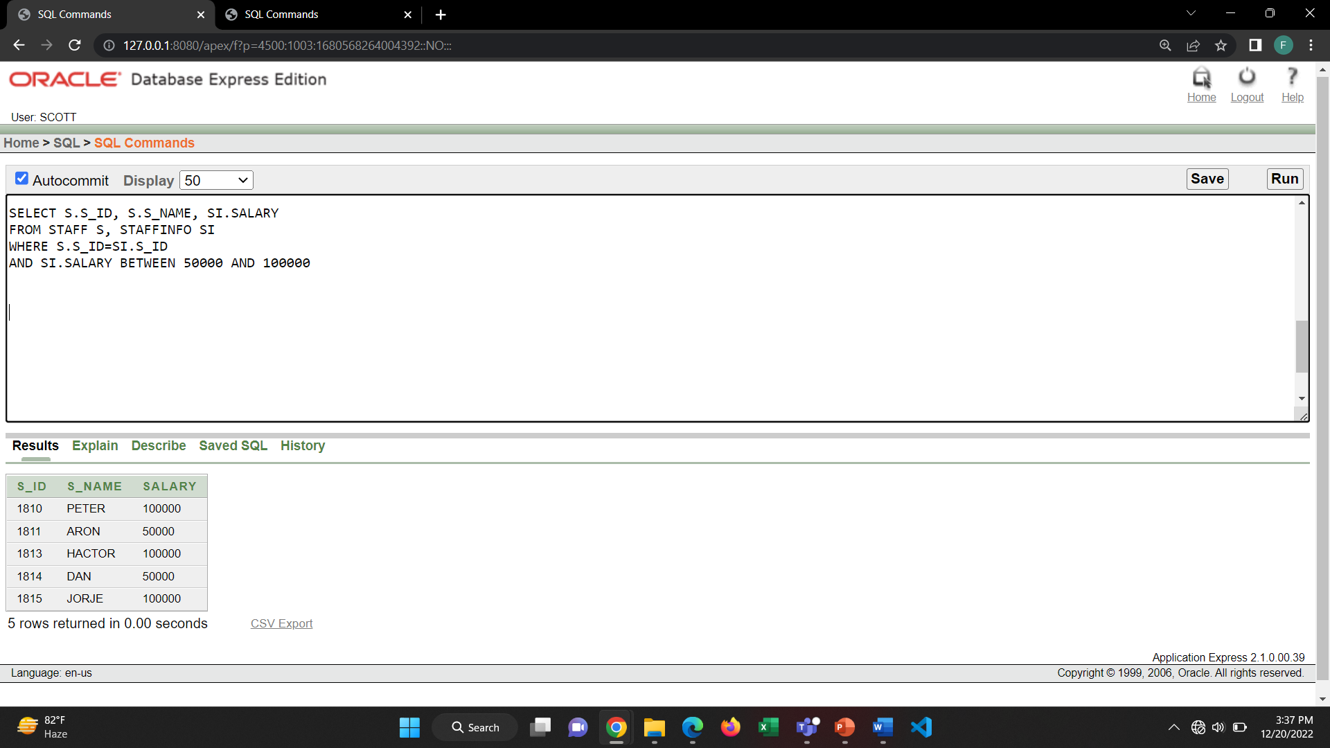2. Show Staff ID, Staff name, Staff salary where salary is between 50000 and 100000

**GROUP FUNCTION**:

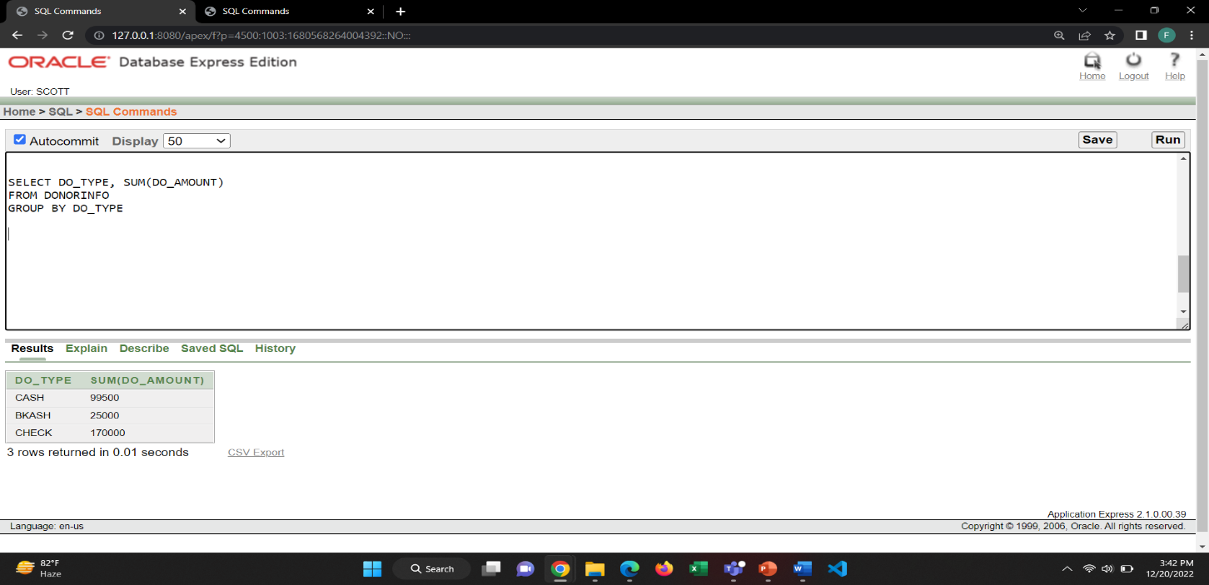1. Show the Donation Type and Sum of total donation group by Donation Type from the DONORINFO table.

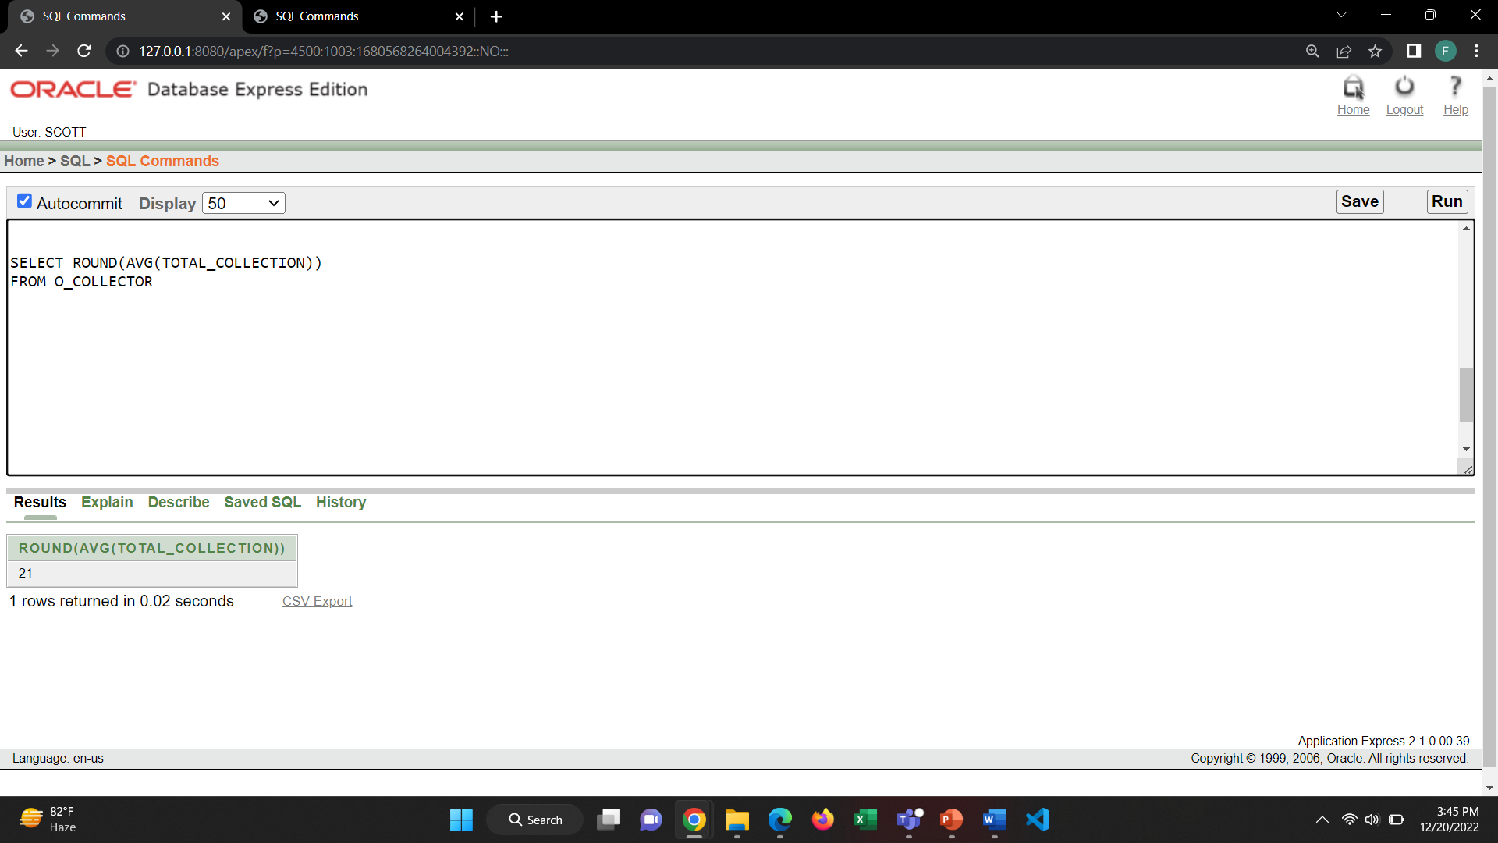2. Show the average of the total collection of the orphan collectors.

**CREATE VIEW:**

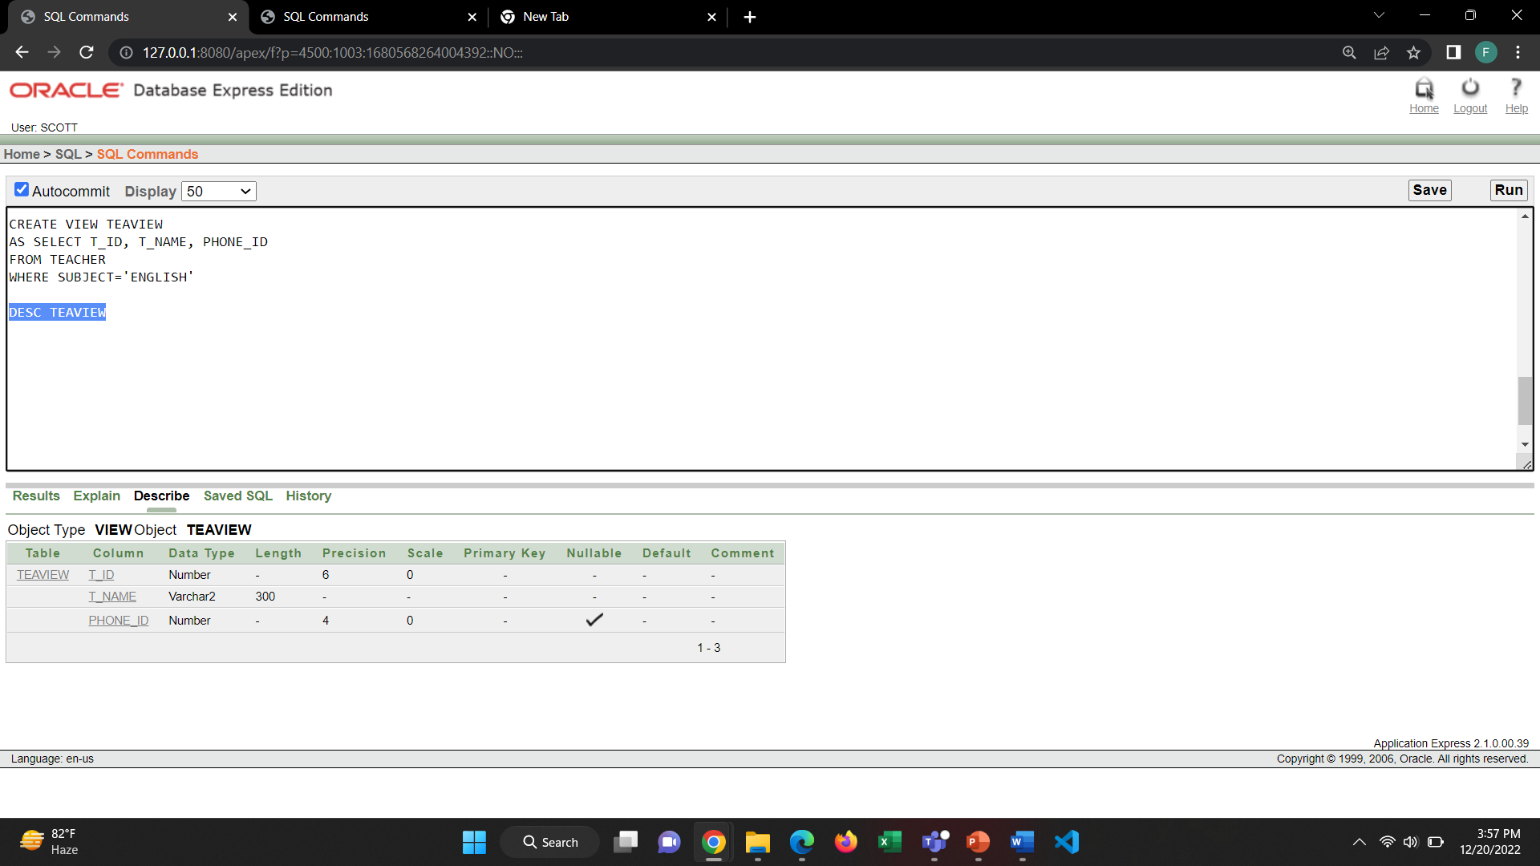1. Create a view of T_ID, T_NAME, PHONE _ID from the TEACHER table where subject is ENGLISH.

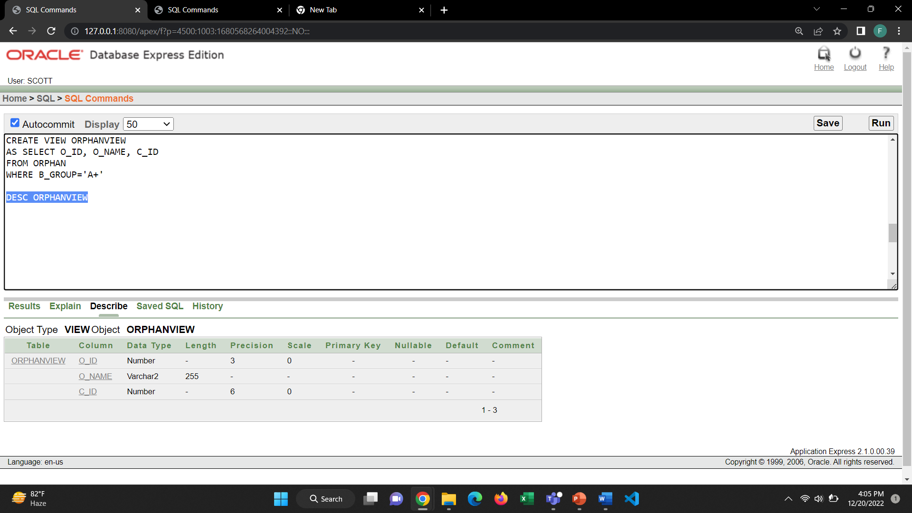2. Create a view of O_ID, O_NAME, C_ID from the orphan table where blood group is A+.

**OTHERS:**

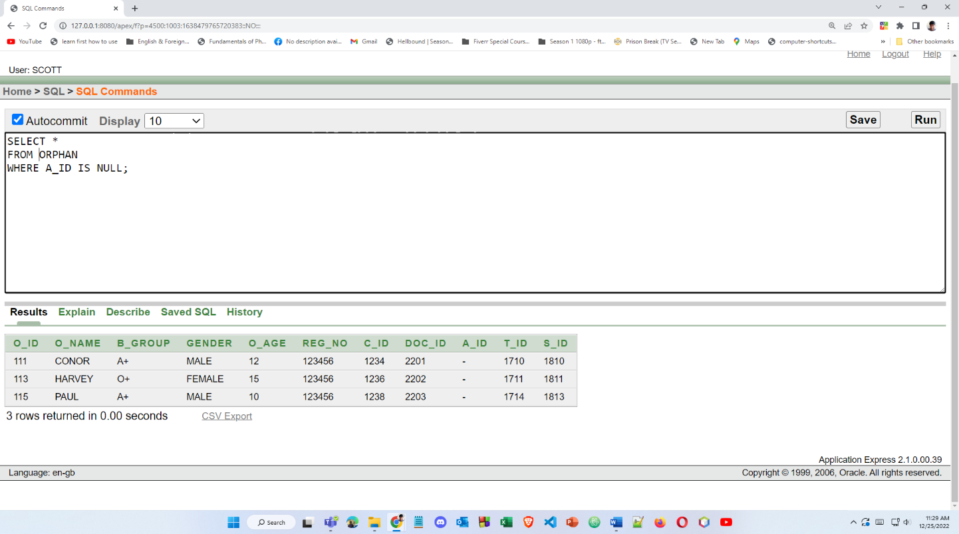1. Show the orphan info who does not have an ADOPTER.

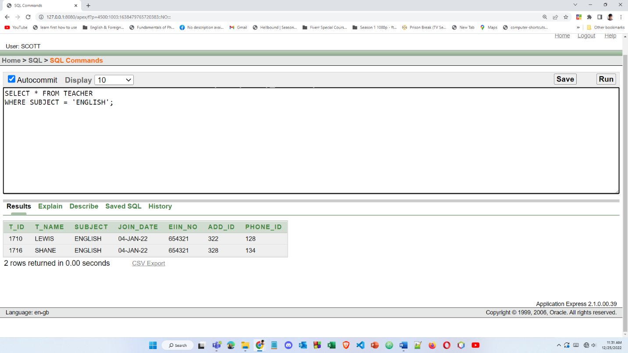2. Show the teacher info whose subject is ENGLISH.